**(SE - Fundamentals of Programming)**

{C Language} -

‘FundamentalsOf Programing’

MODULES:- [3.1,3.2,3.3]

**Submitted to :-**

**Ms. Heena Malek**

**Submitted by :-**

**Ankita Sahu**

**MODULE: 3.1 (C Language Fundamental)**

**1.** **Display This Information using printf** :

**i) Your Name**

**ii) Your Birth date**

**iii) Your Age**

**iv) Your Address**

**Ans :-**

Practical:-

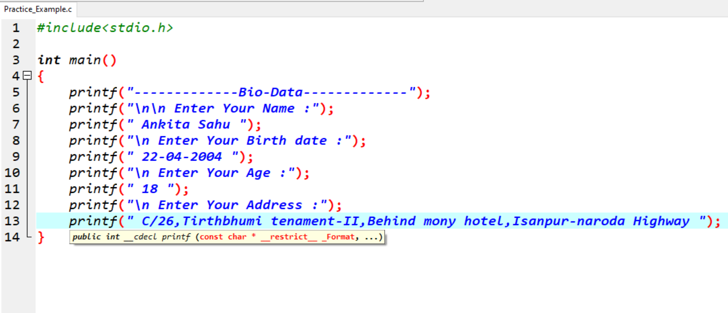

Output:-

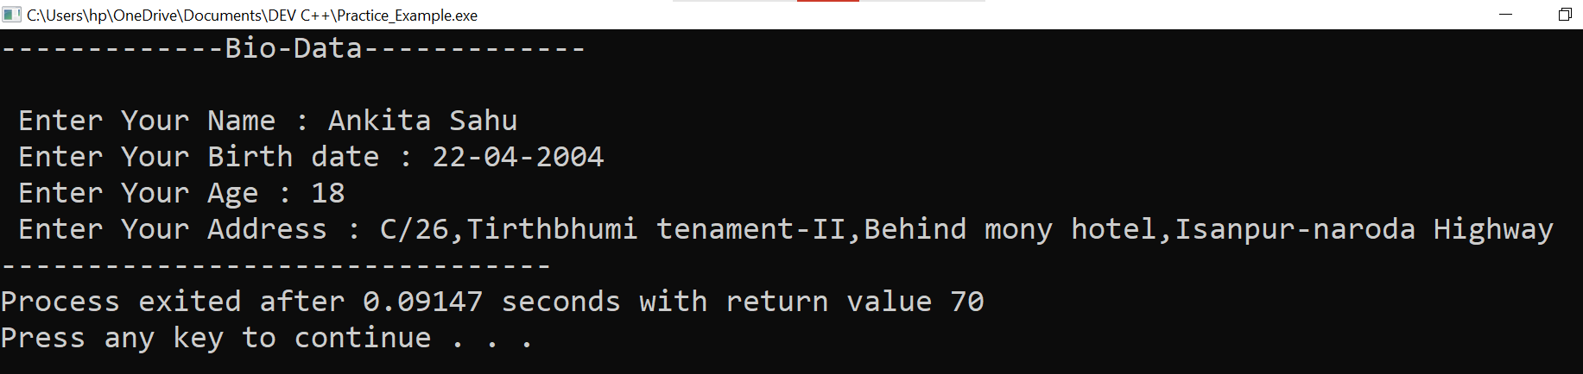

**2. Write a program to make Simple calculator (to make addition, subtraction, multiplication, division and modulo)?**

**Ans:-**

Practical:-

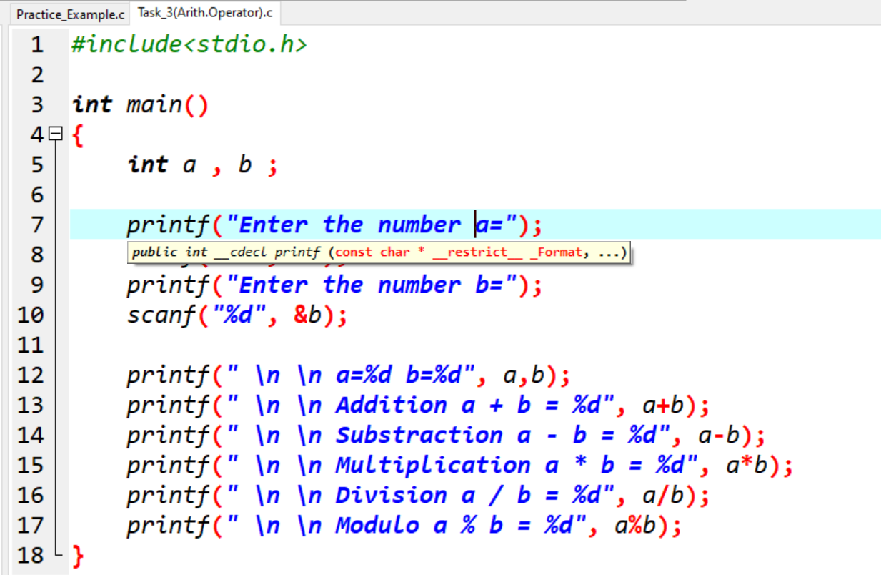

Output:-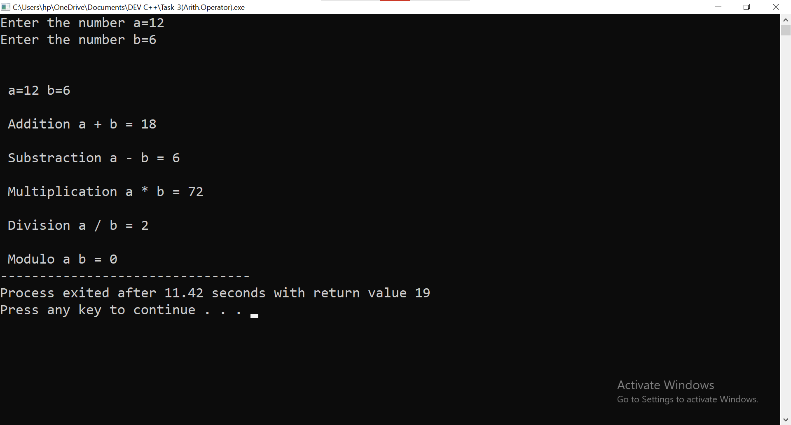

**3. WAP to find area of circle, rectangle and triangle.**

**Ans:-**

**i) Area Of Rectangle:**

Practical:

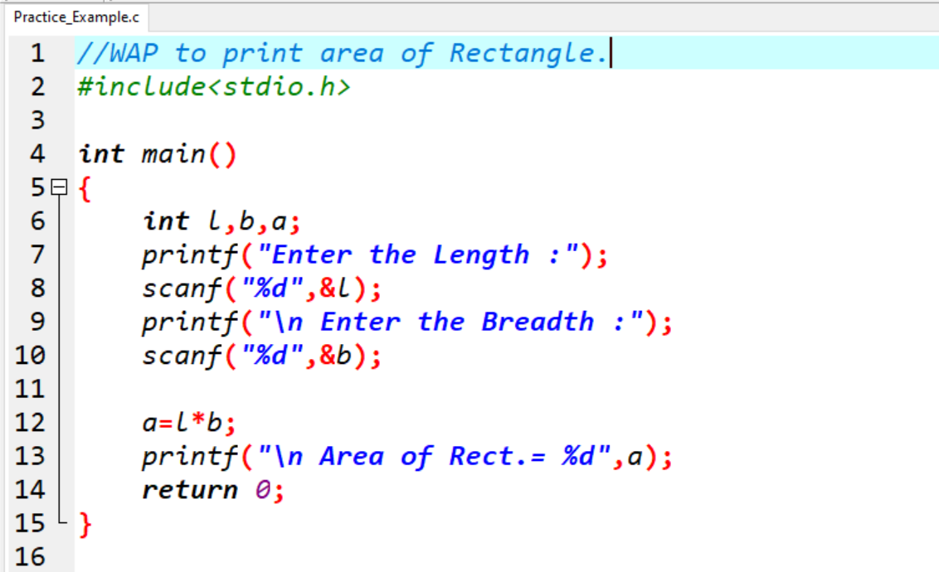

Output: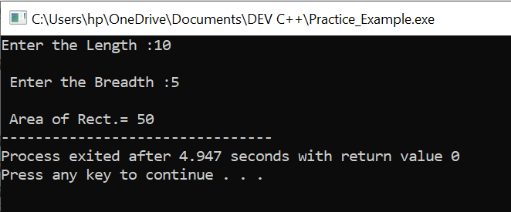

**ii) Area Of Circle:**

Practical:

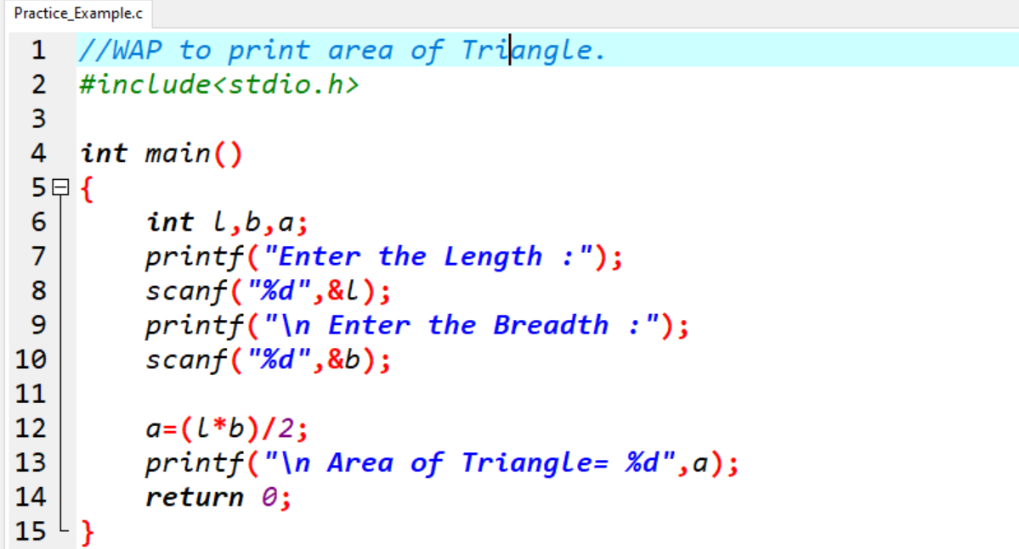

Output:

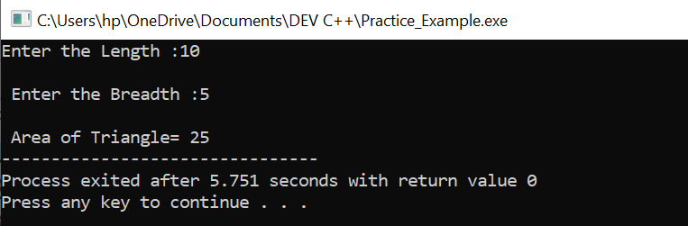

**iii) Area Of Circle:**

Practical:

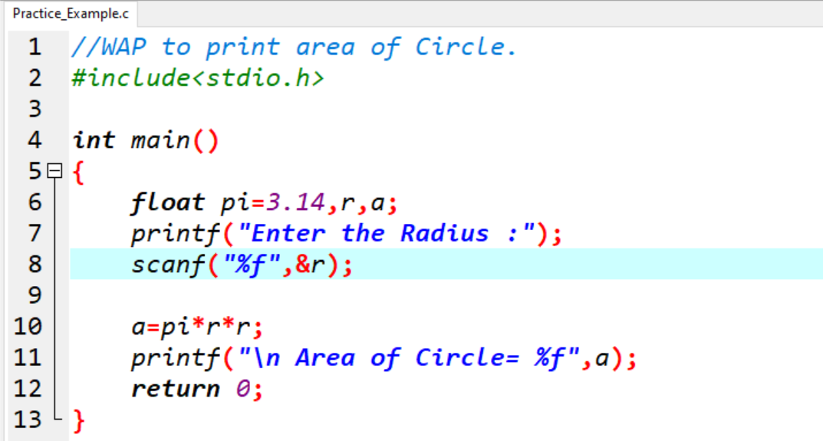

Output:

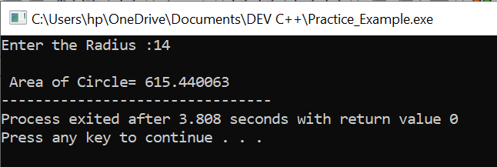

**4. WAP to find simple interest.**

**Ans:-**

**Simple Interest:**

Practical:

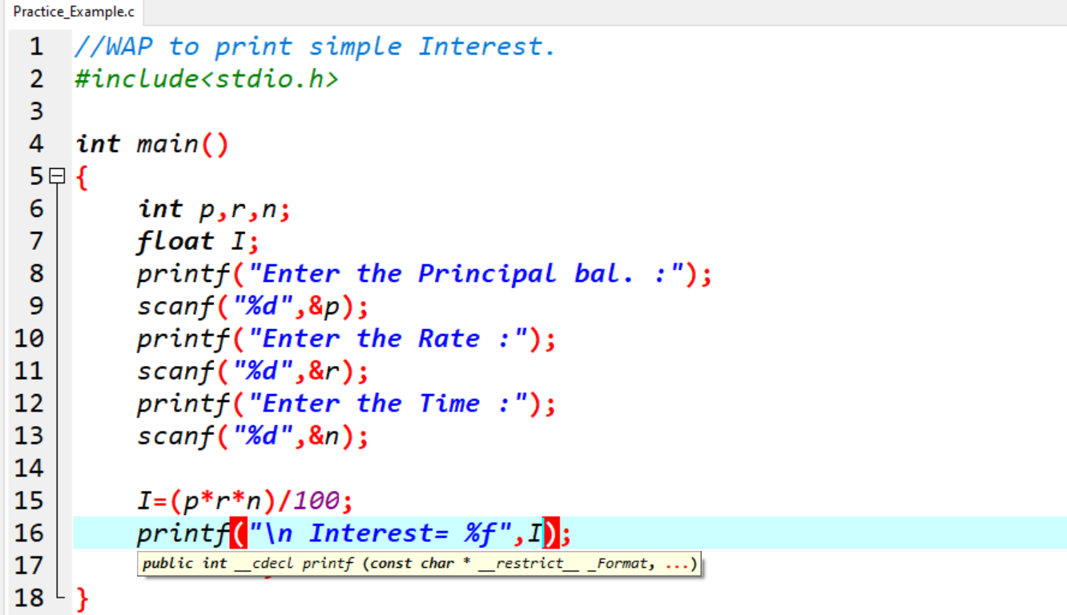

Output:

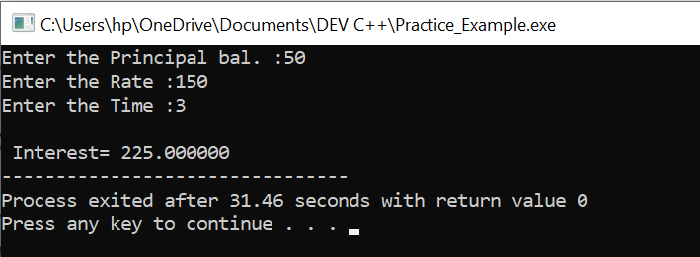

**5. WAP to check if the given year is a leap year or not.**

**Ans:-**

Practical:

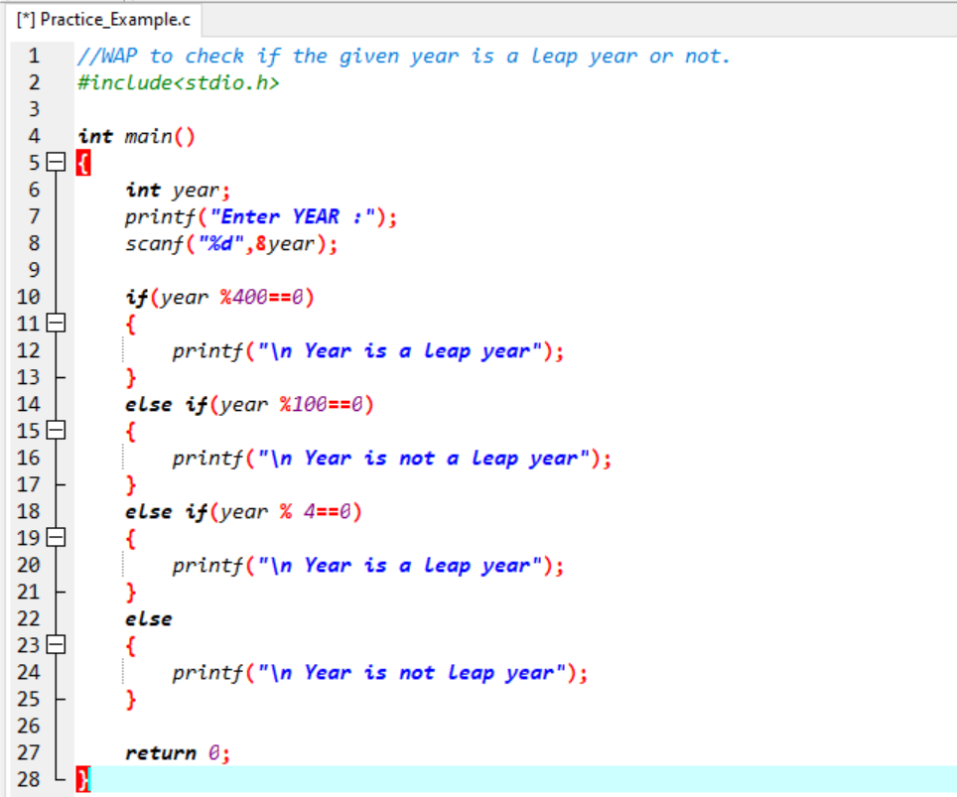

Output:

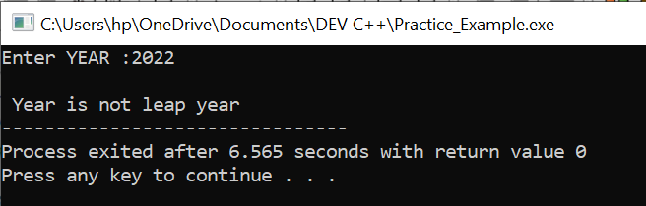

**MODULE: 3.2 (C Language Programing with C)**

**1.** **WAP to make simple calculator (operation include Addition, Subtraction, Multiplication, Division, modulo).**

**Ans:-**

Practical:

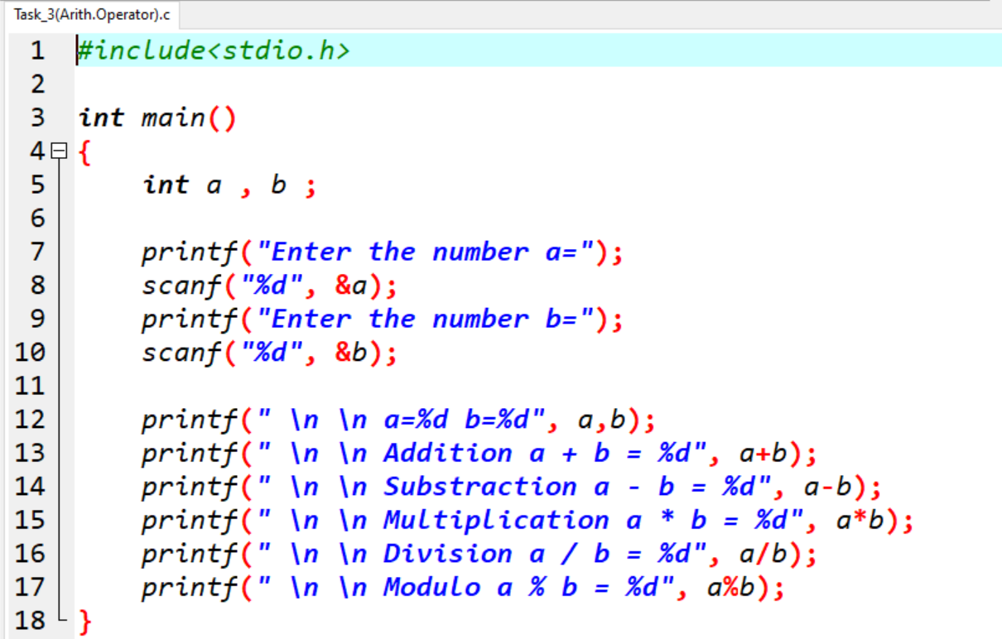

Output: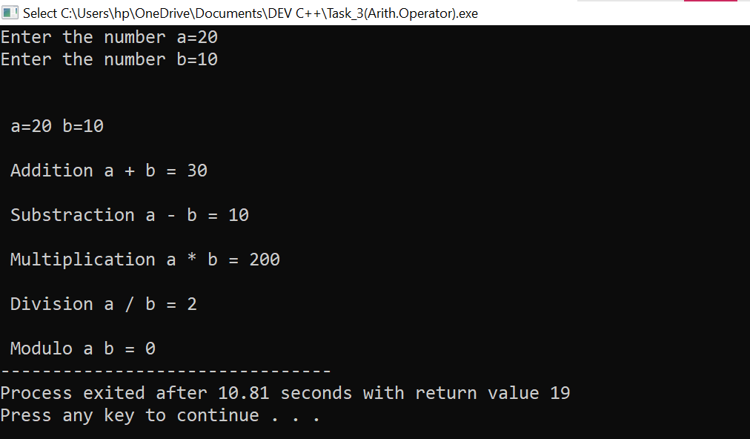

**2.** **WAP to swap two numbers without using third variable.**

**Ans:-**

Practical:

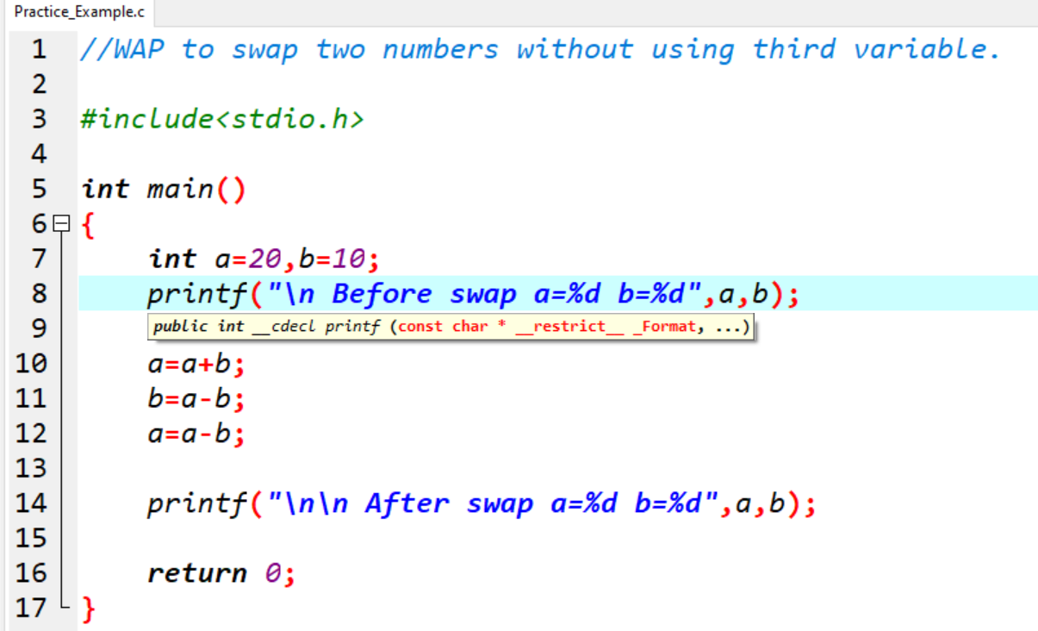

Output:

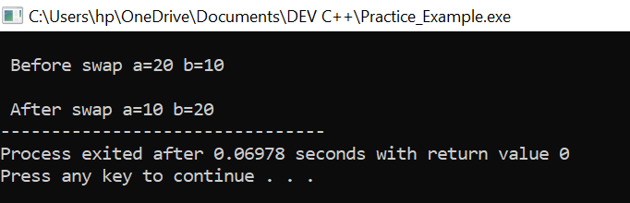

**3.** **WAP to find number is even or odd using ternary operator.**

**Ans:-**

Practical:-

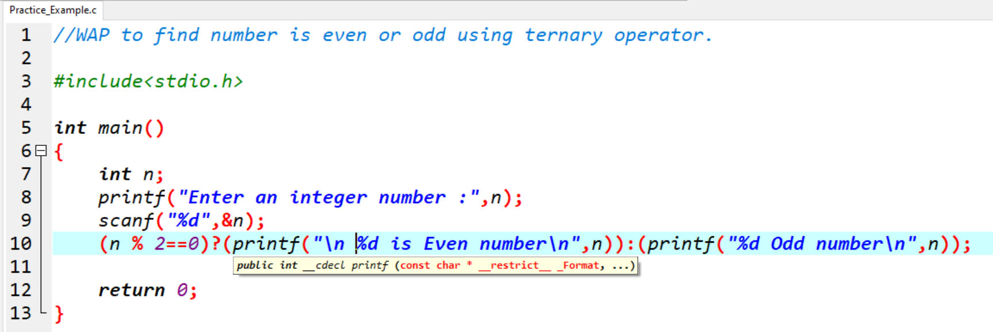

Output:

[EVEN]:-

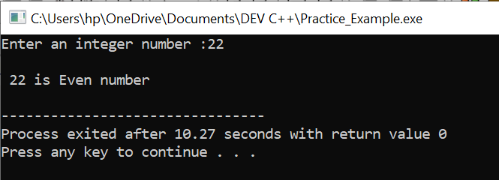

[Odd]:-

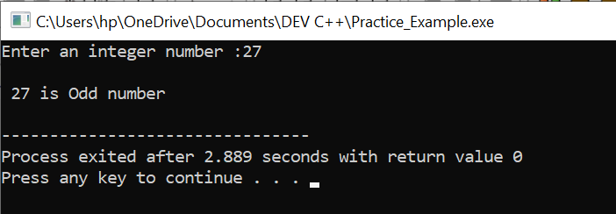

**4. WAP to show:-**

**1. Monday to Sunday using switch case.**

**2. Vowel or Consonant using switch case.**

**Ans:-**

1. **Monday to Sunday using switch case.**

Practical:-

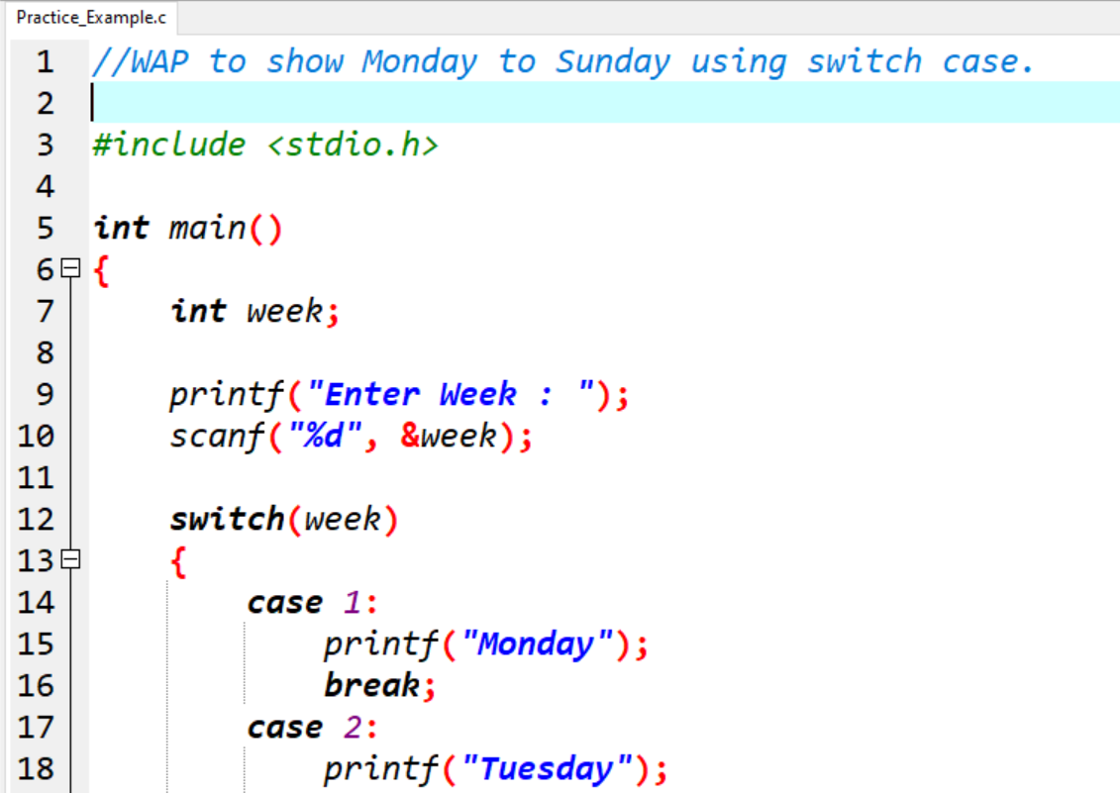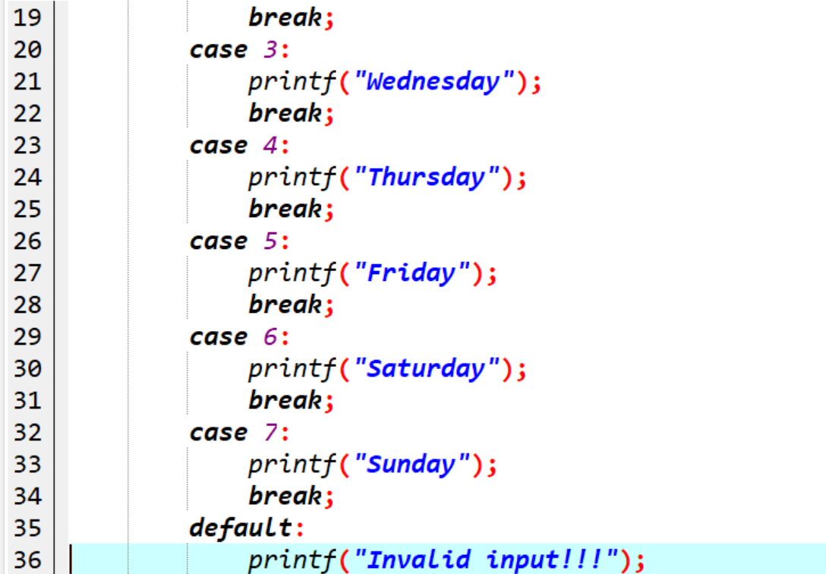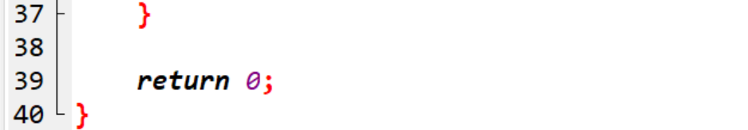

Output:

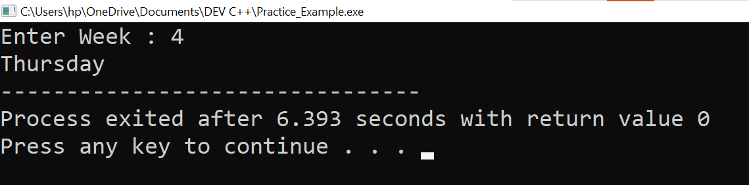

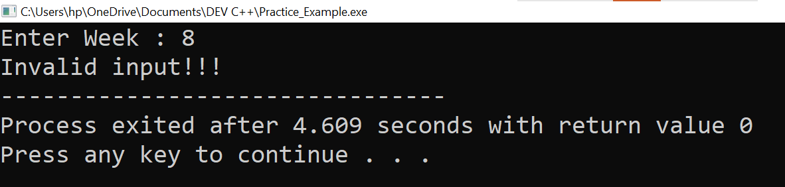

**2. Vowel or Consonant using switch case.**

Practical:

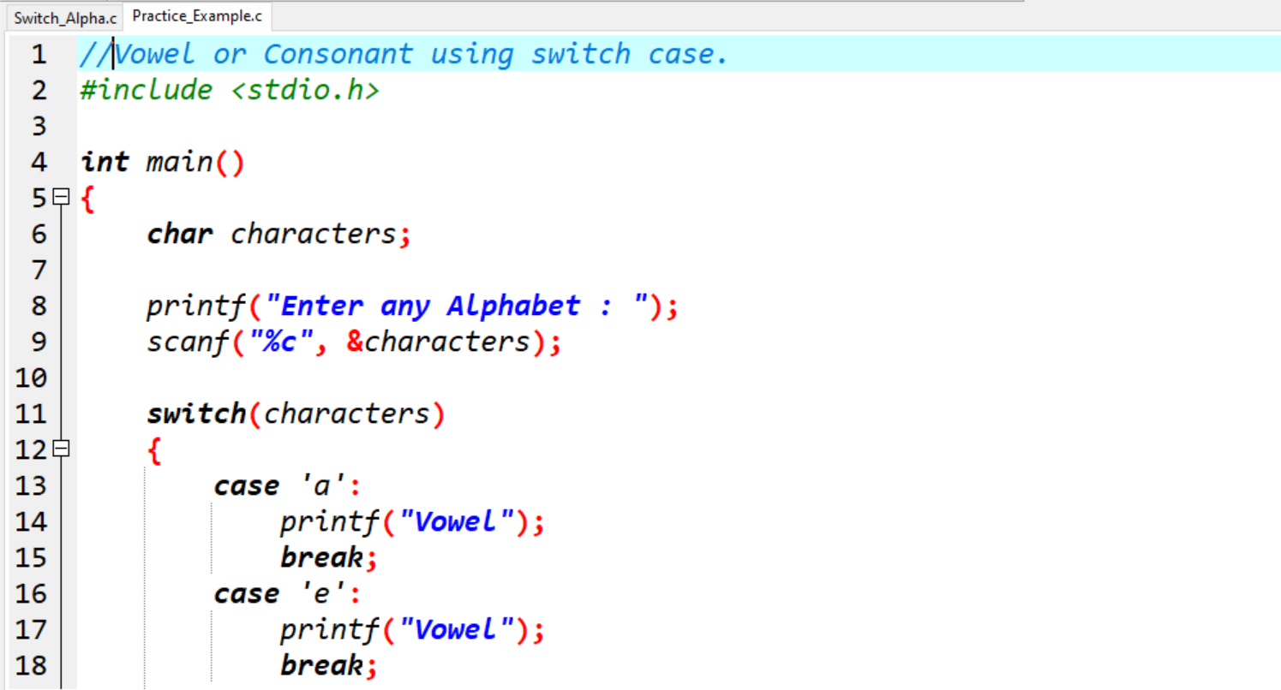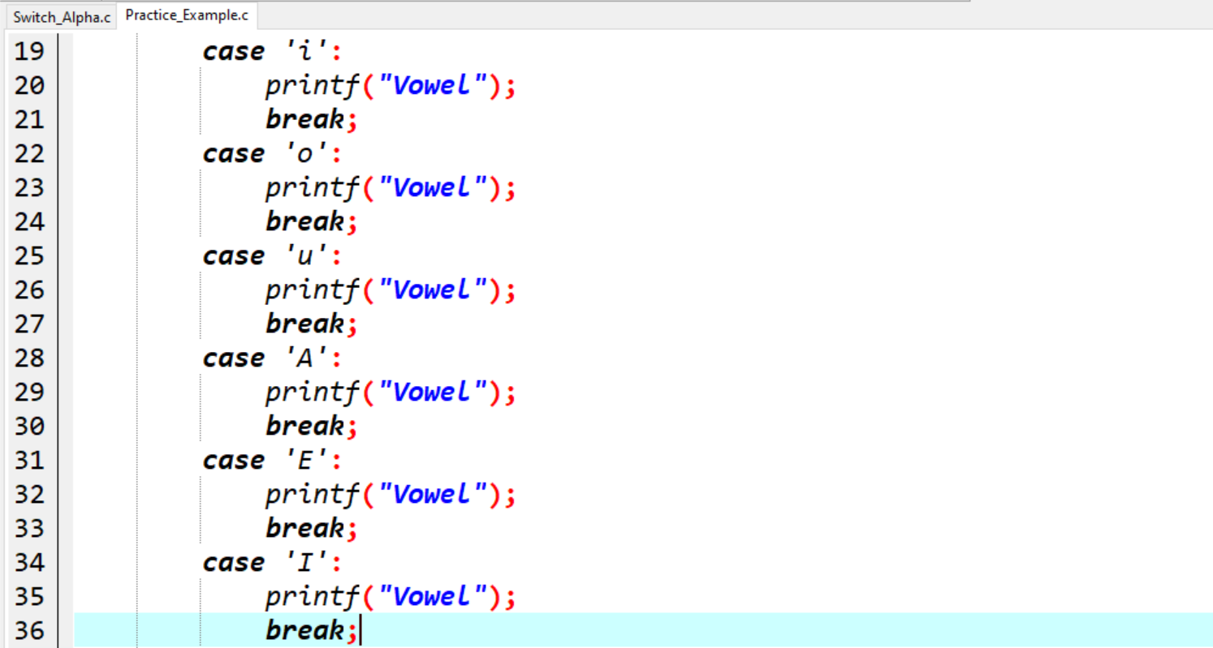

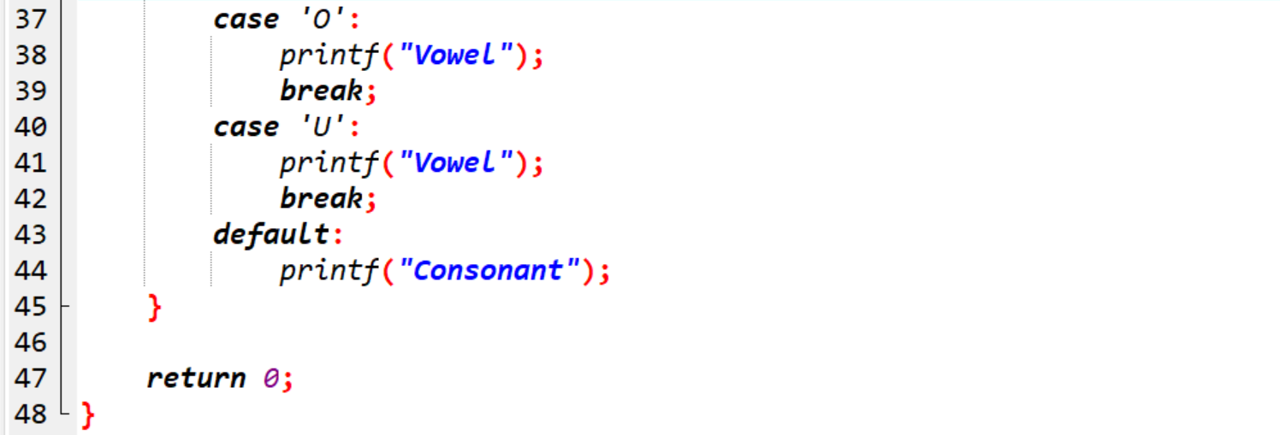

Output:

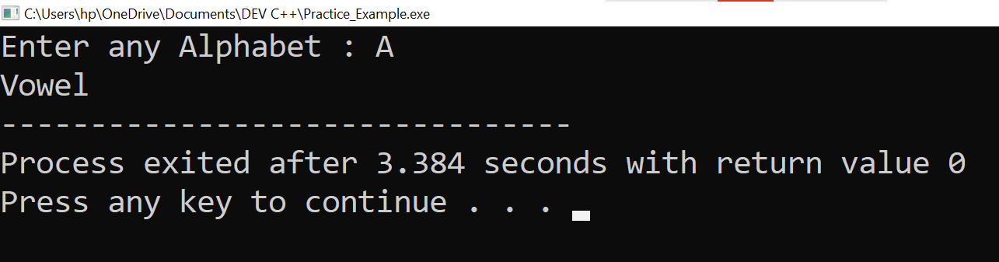

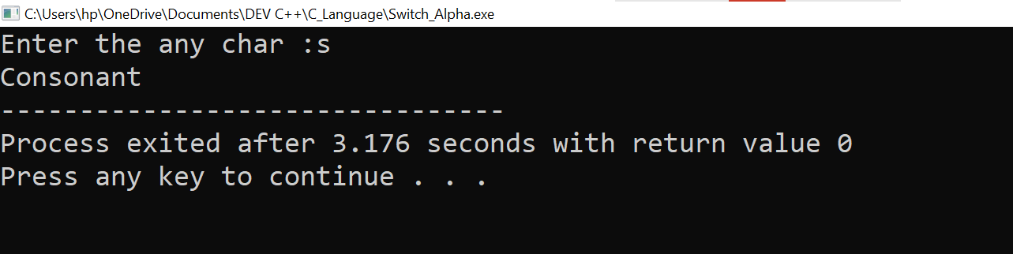

**5. Looping programs:**

**1. WAP to print 972 to 897 using for loop.**

**2. WAP to take 10 no. Input from user and find out..**

**i. How many Even numbers are there.**

**ii. How many odd numbers are there.**

**iii. Sum of even numbers.**

**iv. Sum of odd numbers.**

**v. WAP to print table up to given numbers.**

**Ans:-**

1. **WAP to print 972 to 897 using for loop.**

Practical:

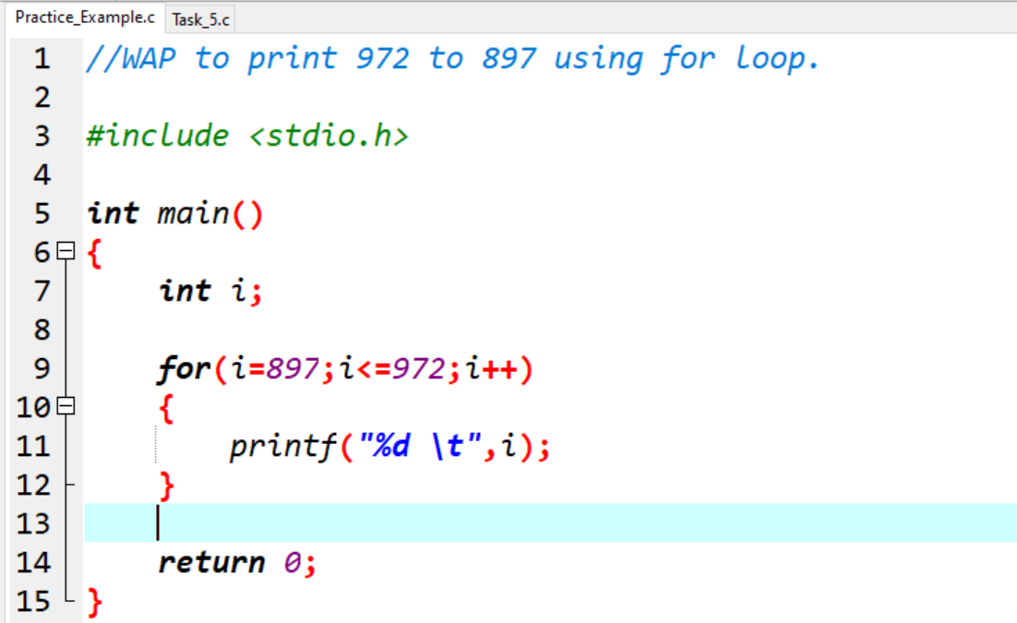

Output:

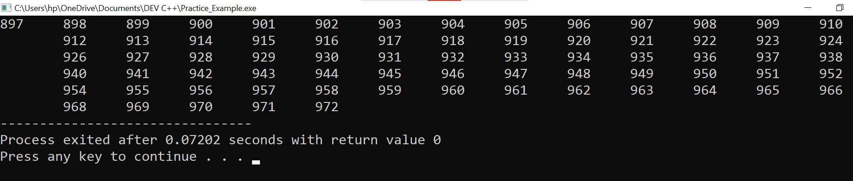

**2. WAP to take 10 no. Input from user and find out..**

**i. How many Even numbers are there.**

Practical:

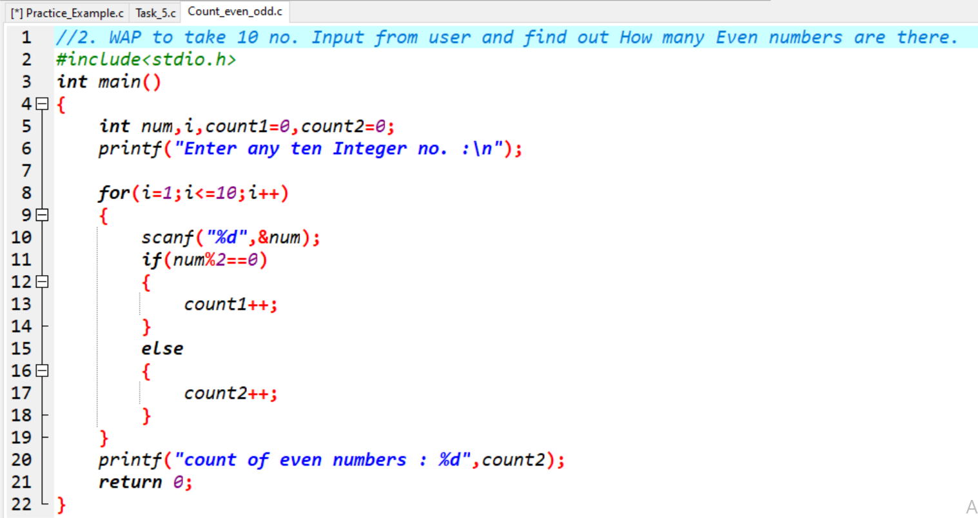

Output: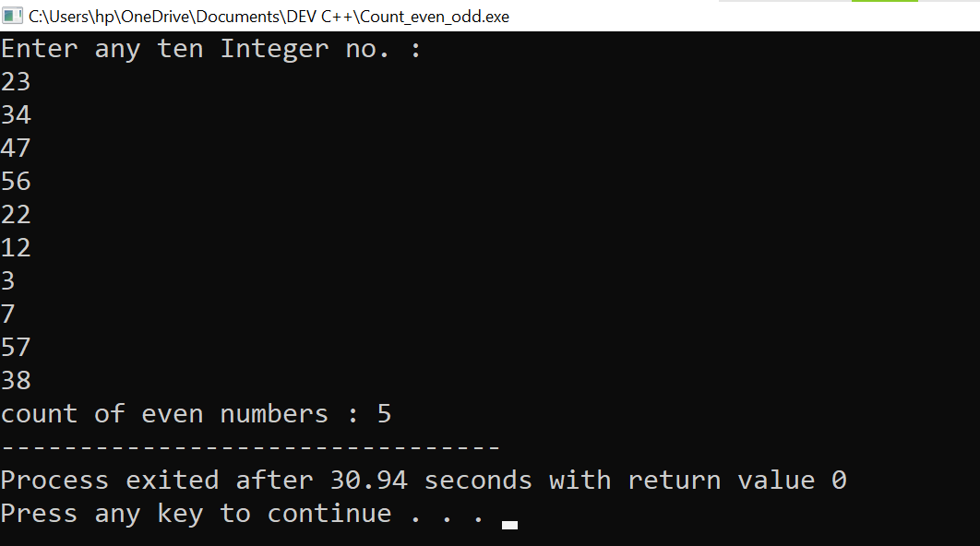

**ii. How many odd numbers are there.**

Practical:

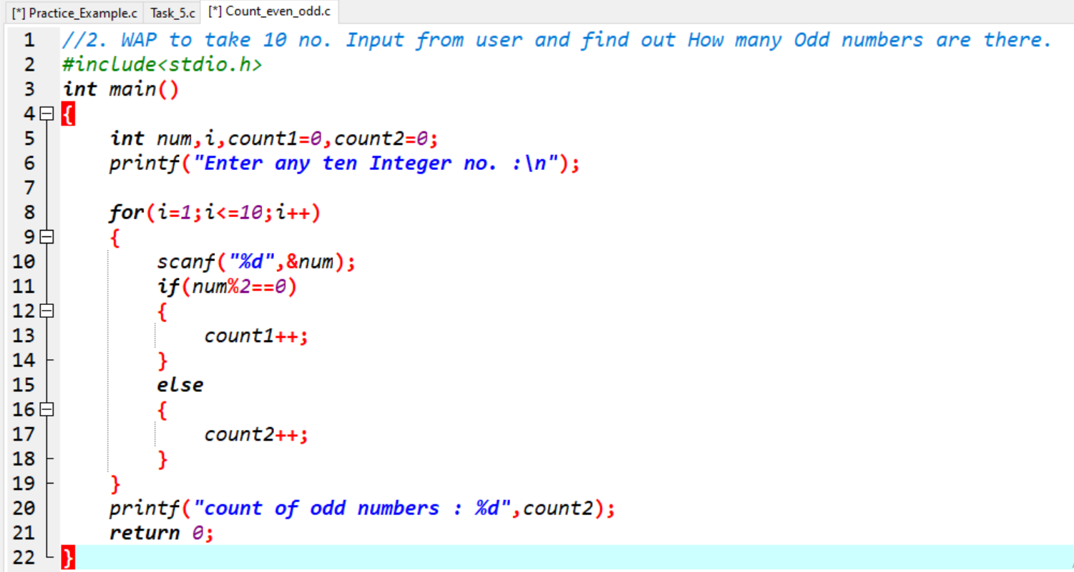

Output: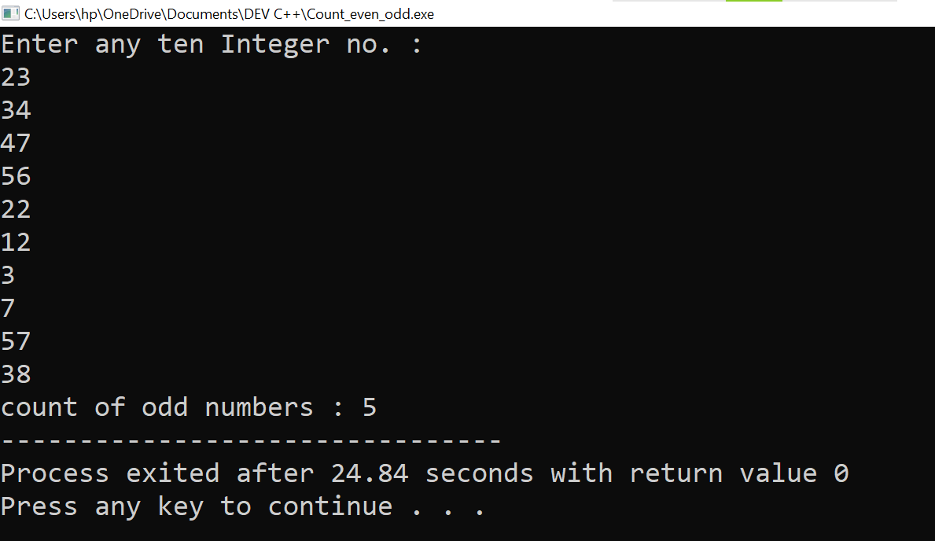

**iii. Sum of even numbers.**

**iv. Sum of odd numbers.**

Practical:

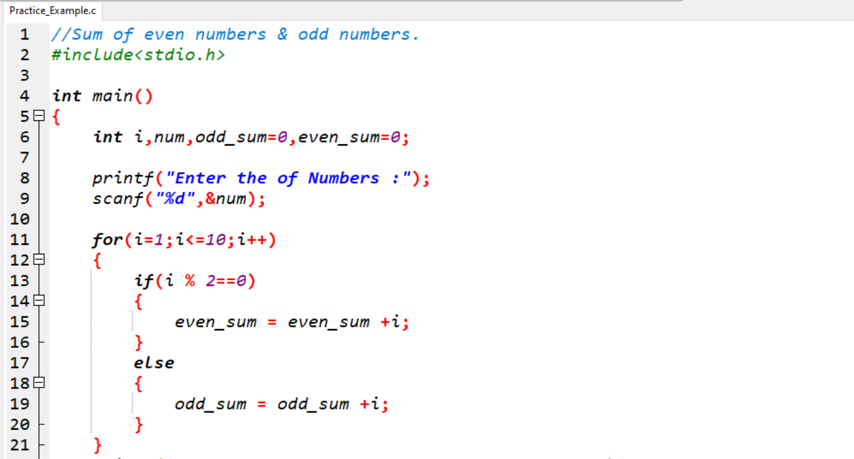

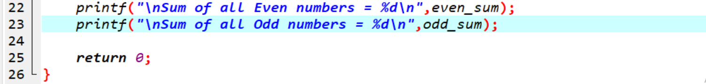

Output:

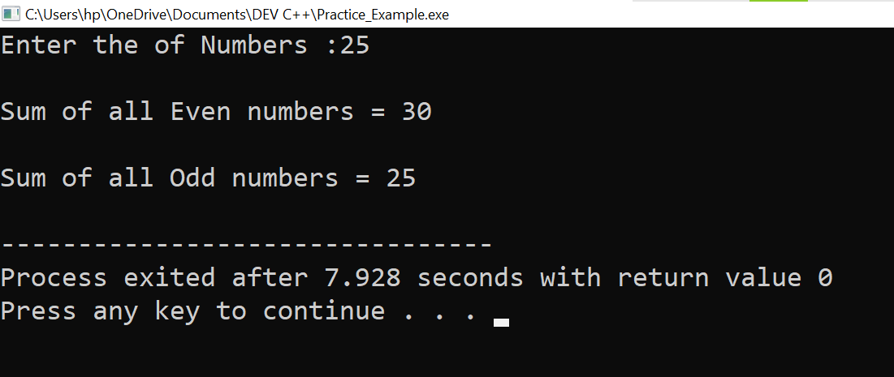

**6. WAP to print table up to given numbers.**

**Ans:-**

Practical:

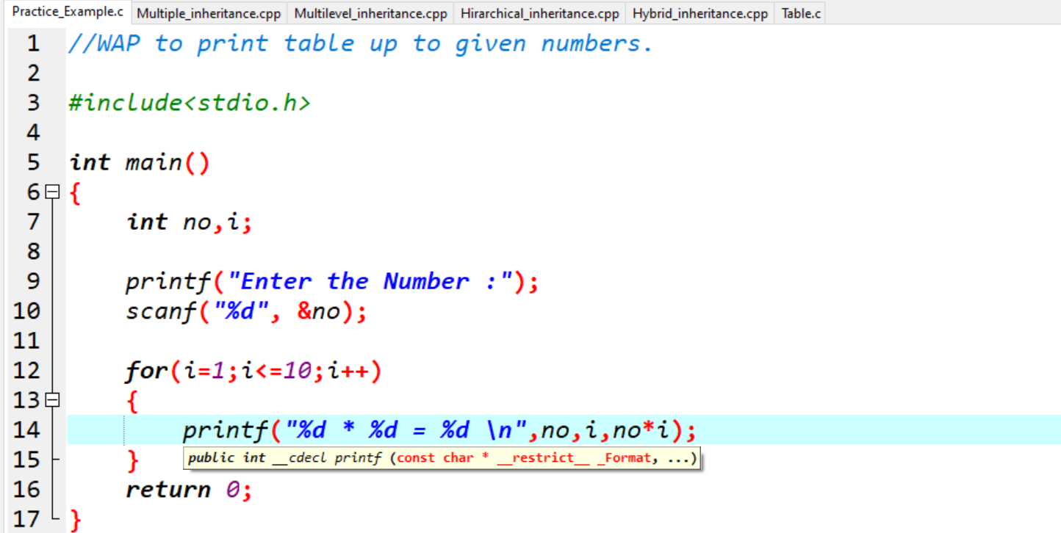

Output:

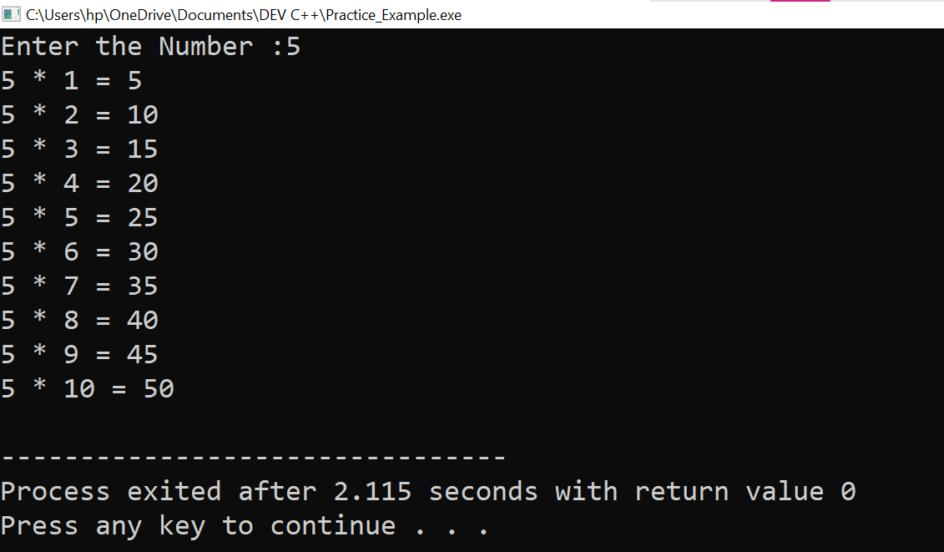

**7. WAP to print factorial of given number.**

**Ans:-**

Practical: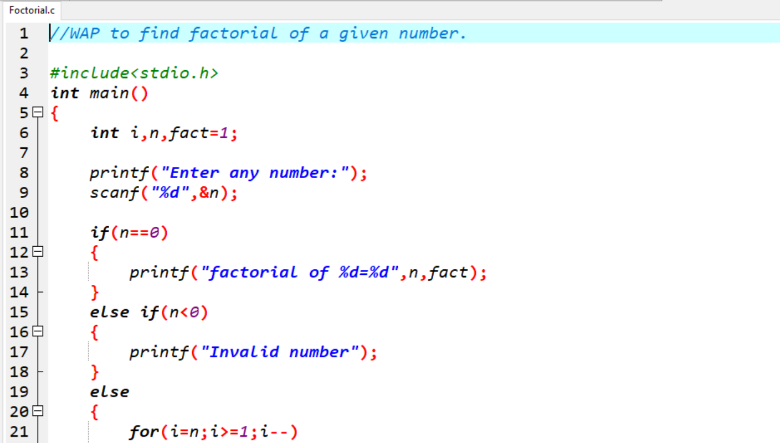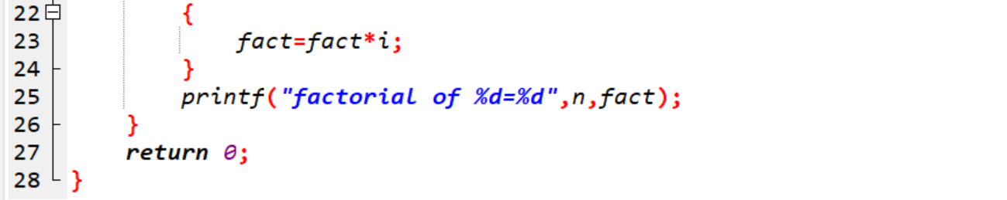

Output:

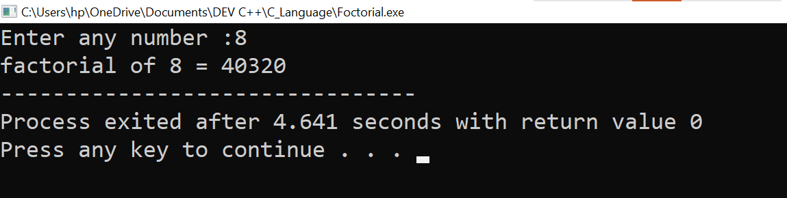

**8.** **WAP to print Fibonacci series up to given numbers.**

**Ans:-**

Practical:

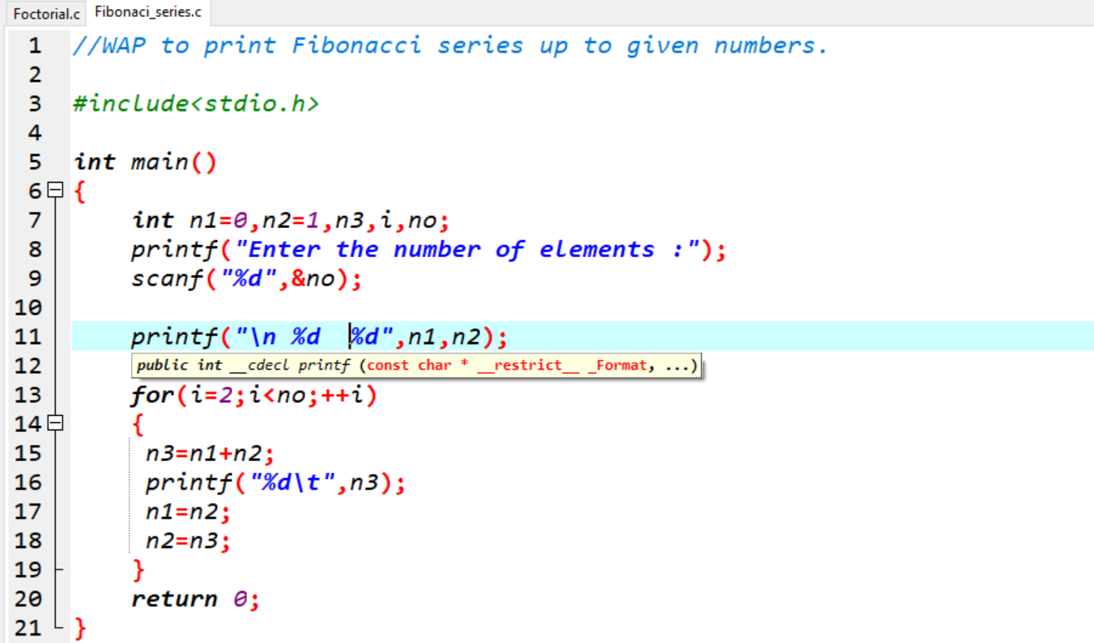

Output:

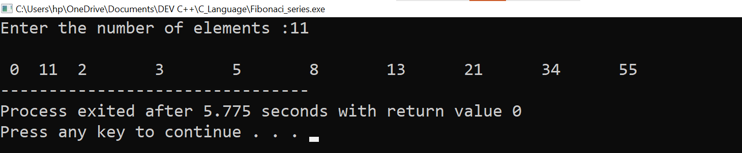

**9.** **WAP to print number in reverse order. (e.g.: number = 64728 ---> reverse = 82746)**

**Ans:-**

Practical:

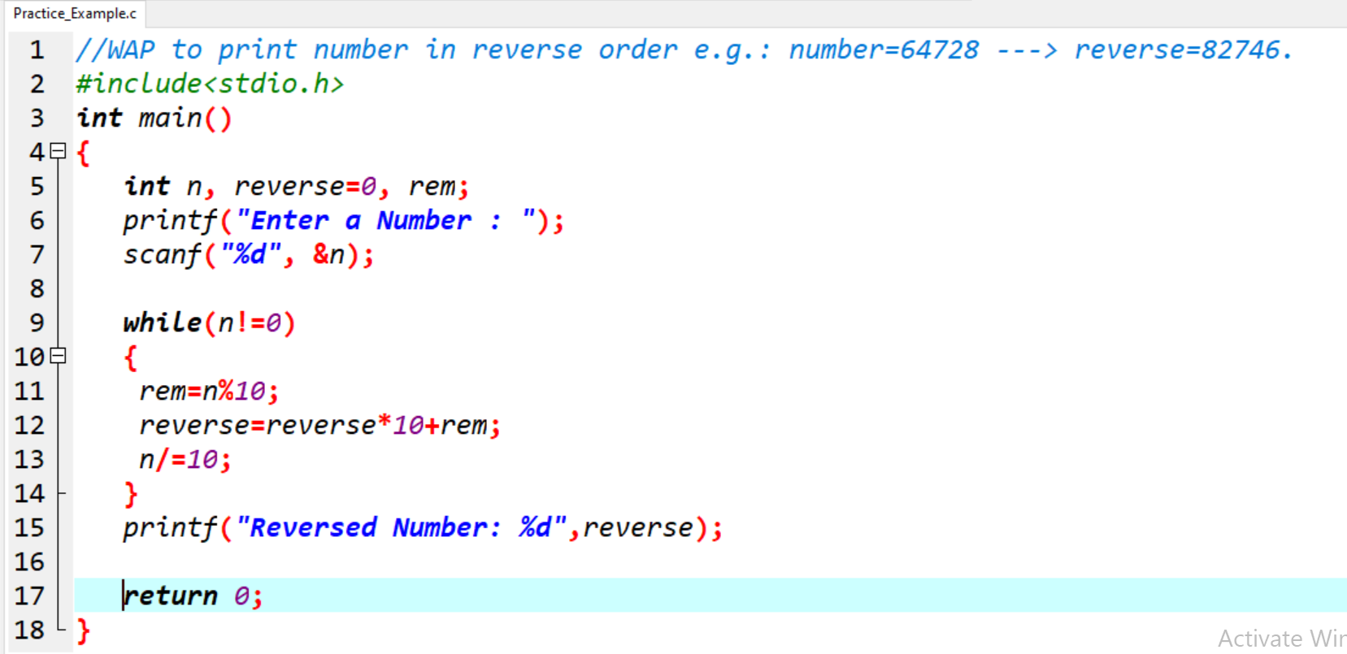

Output:

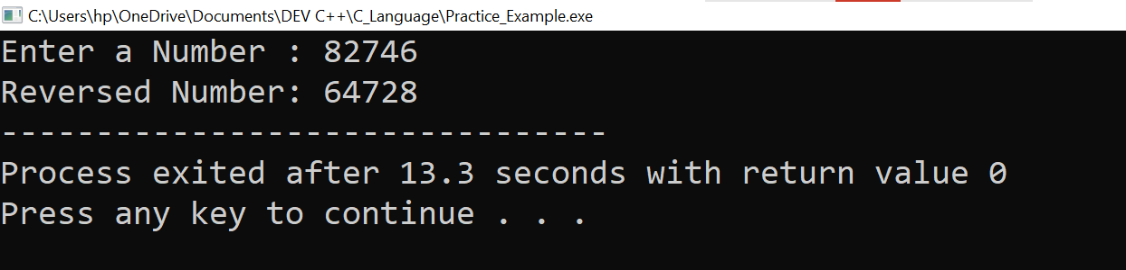

**10. Write a program to find out the max from given number. (E.g., No: -1562 Max number is 6)**

**Ans:-**

Practical:

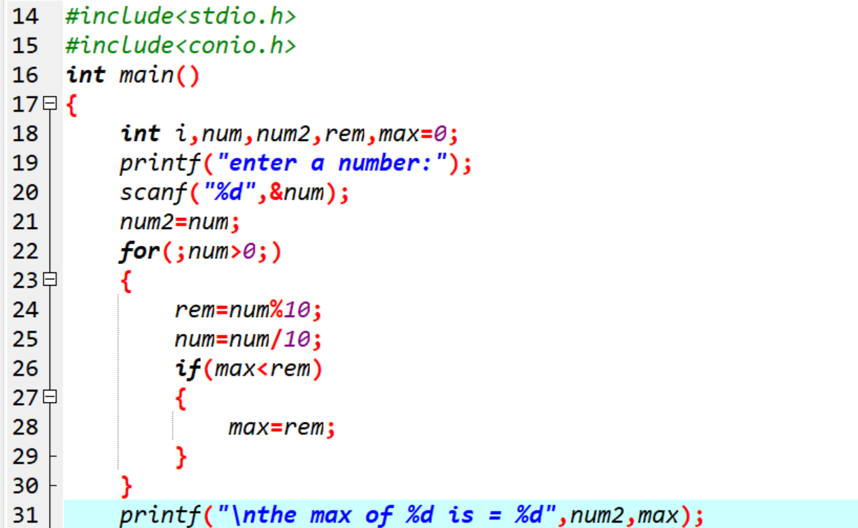

Output:

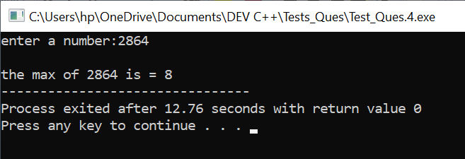

**11.** **Write a program make a summation of given number. (E.g., 1523 Ans: -11)**

**Ans:-**

Practical:

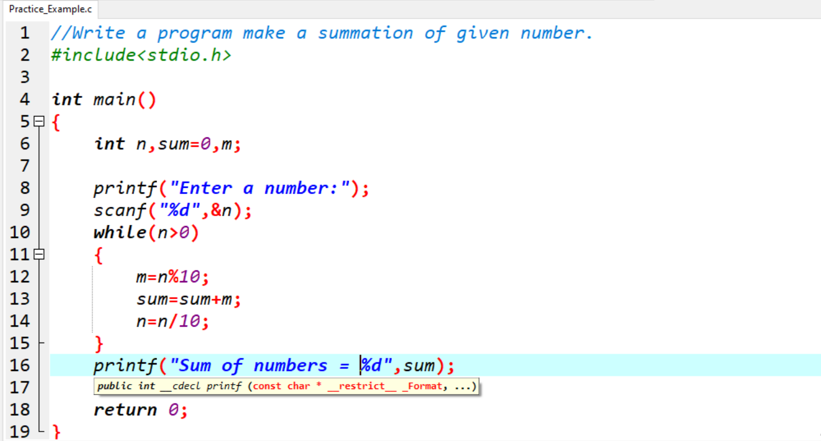

Output:

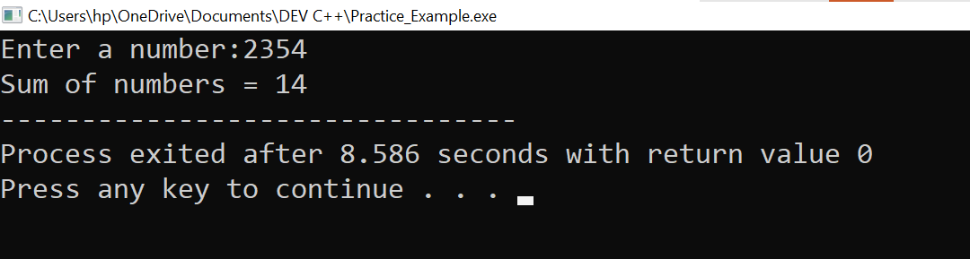

**12. Write a program you have to make a summation of first and last Digit. (E.g., 1234 Ans-:5)**

**Ans:-**

Practical:

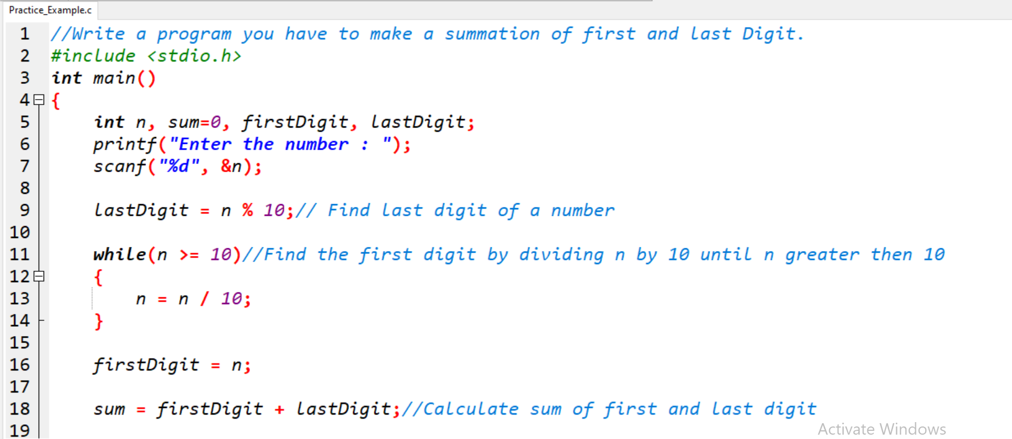

Output:

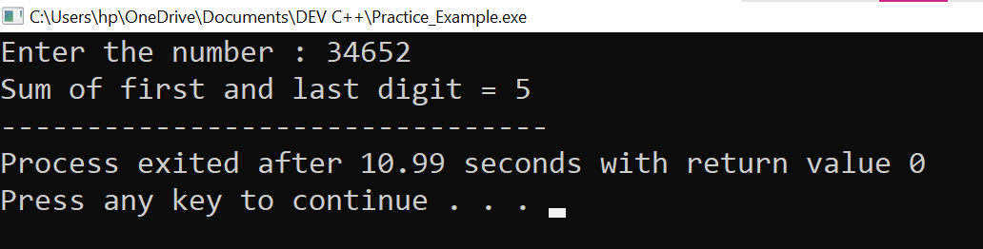

**PATTERNS**

1.

Practical:

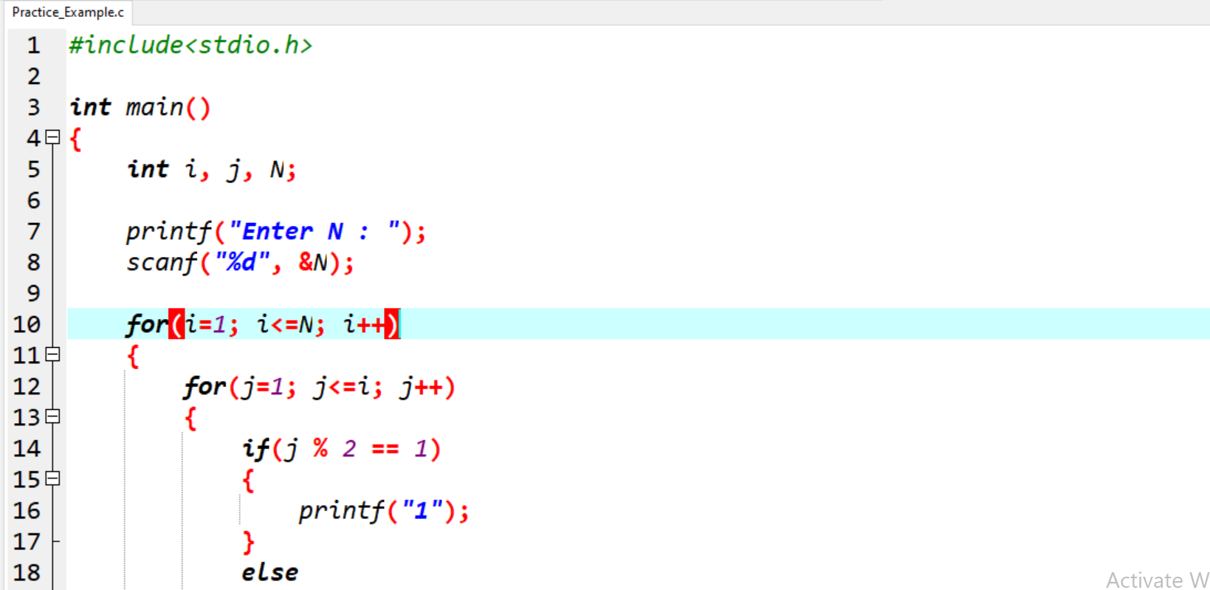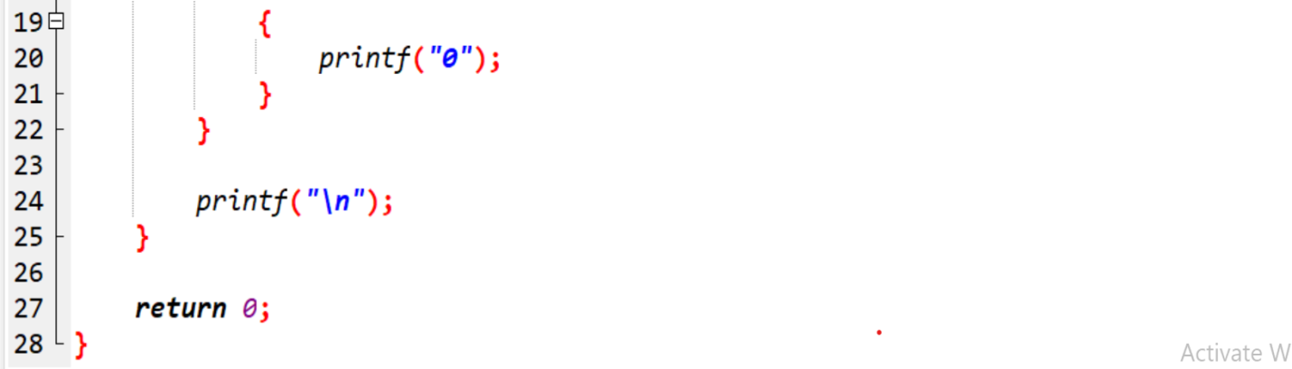

Output:

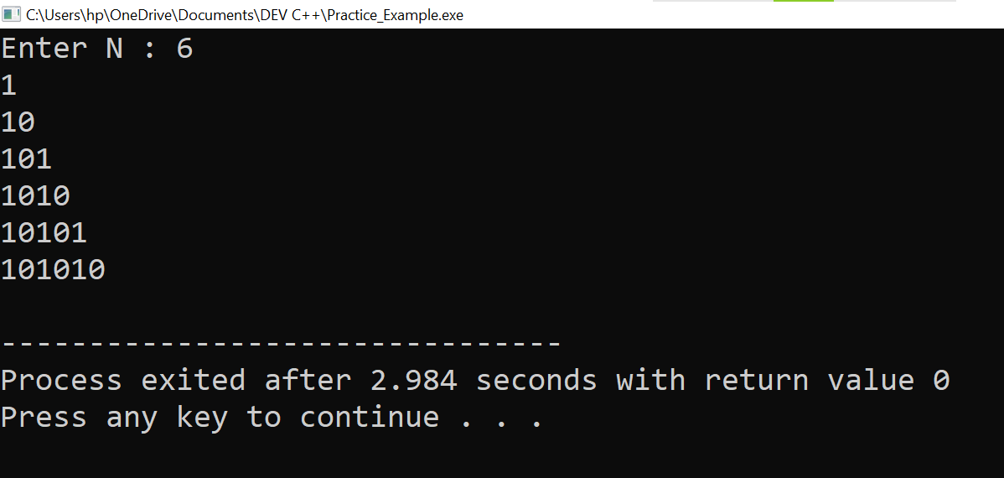

2.

Practical:

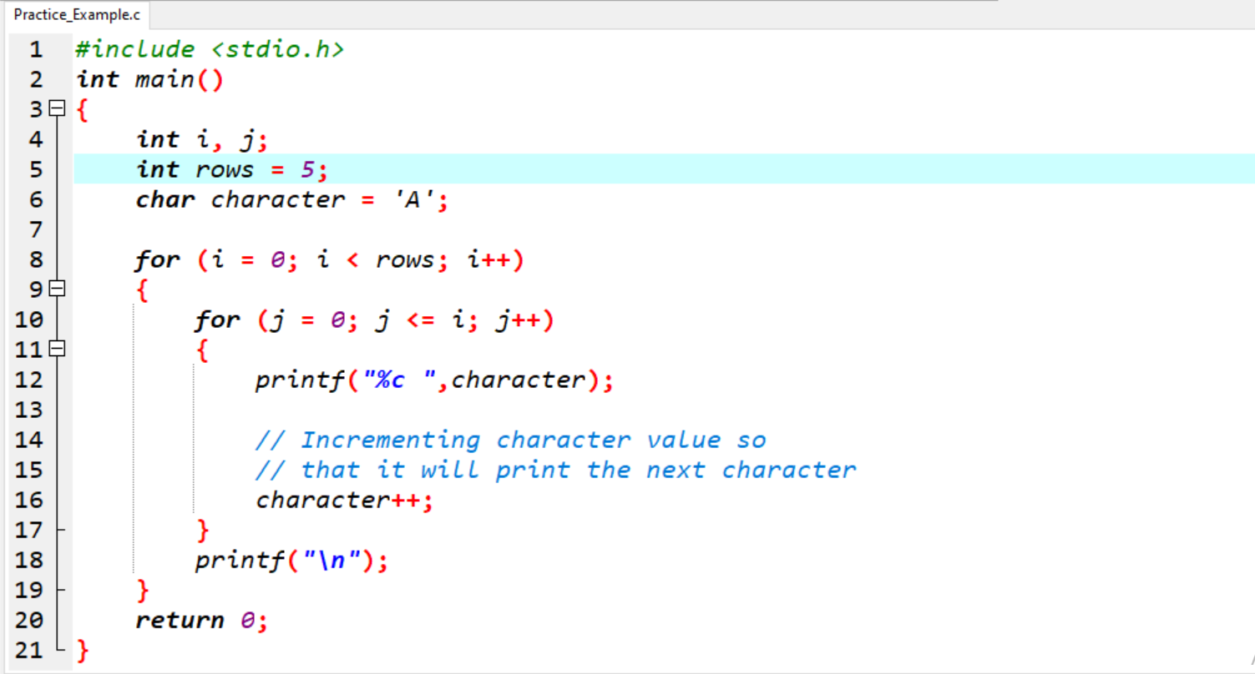

Output:

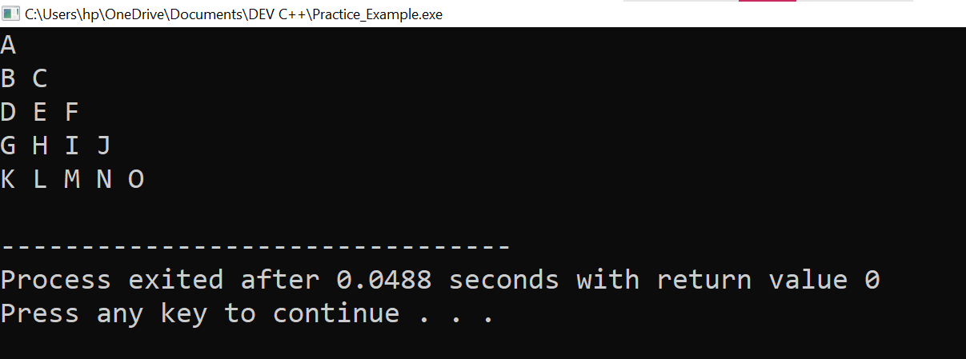

3.

Practical:

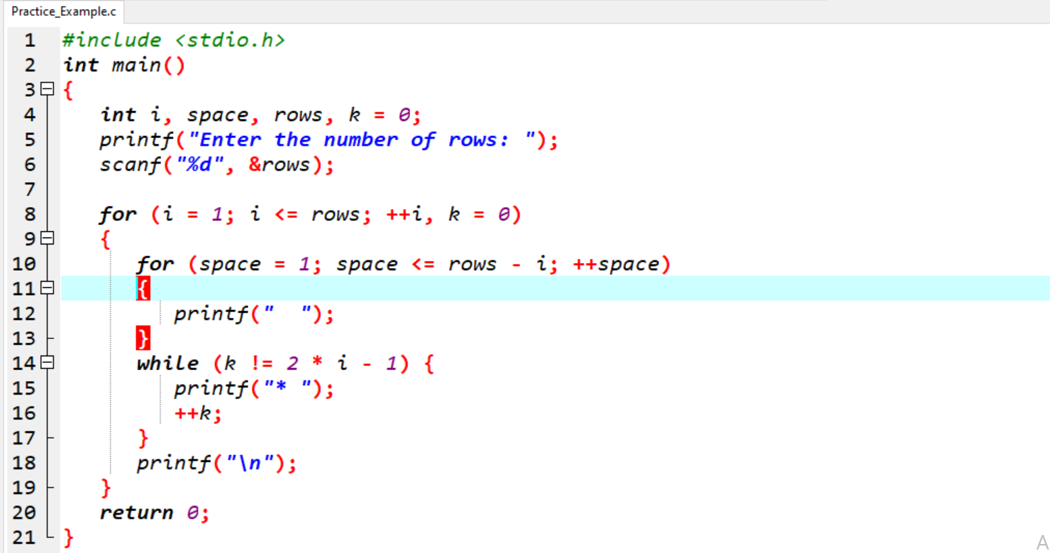

Output:

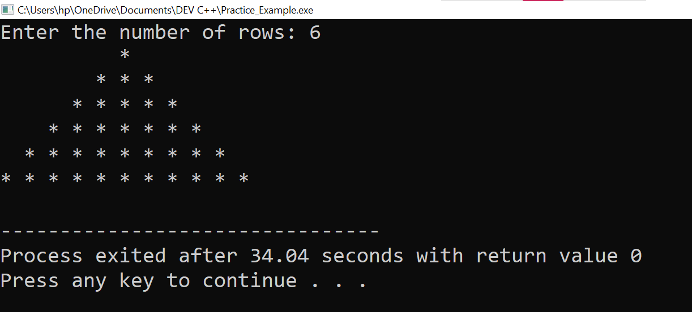

4.

Practical:

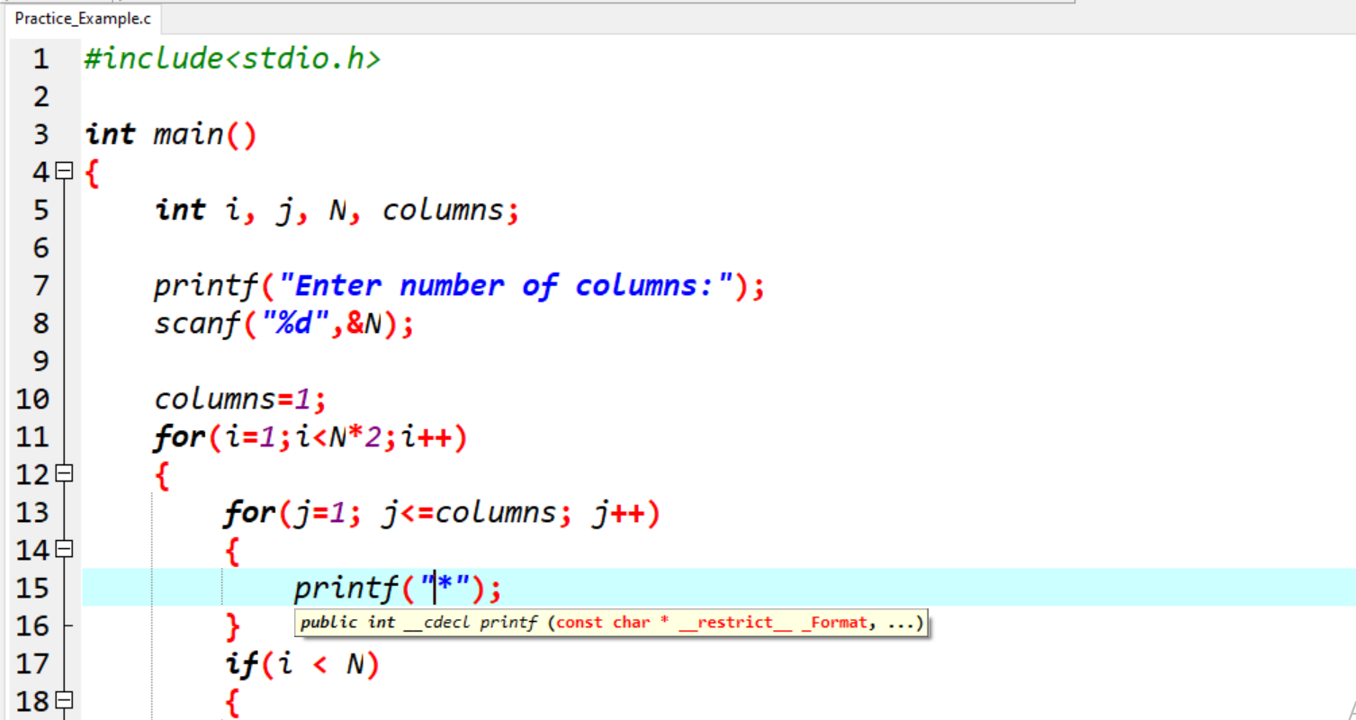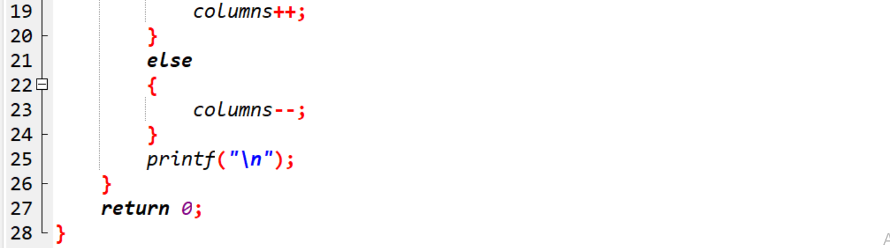

Output:

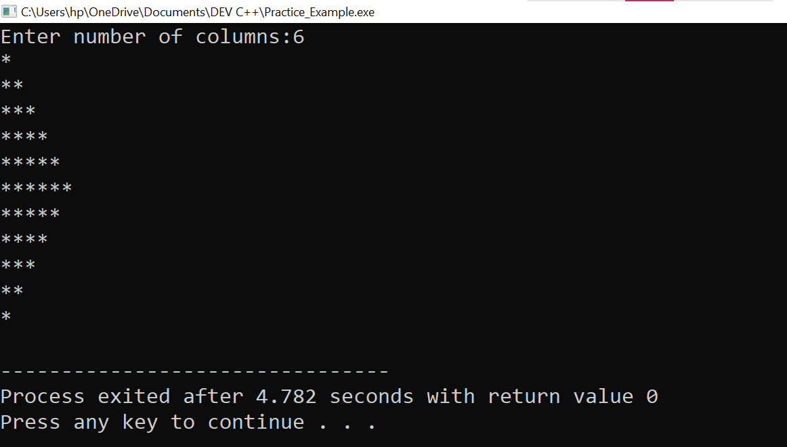

5.

Practical:

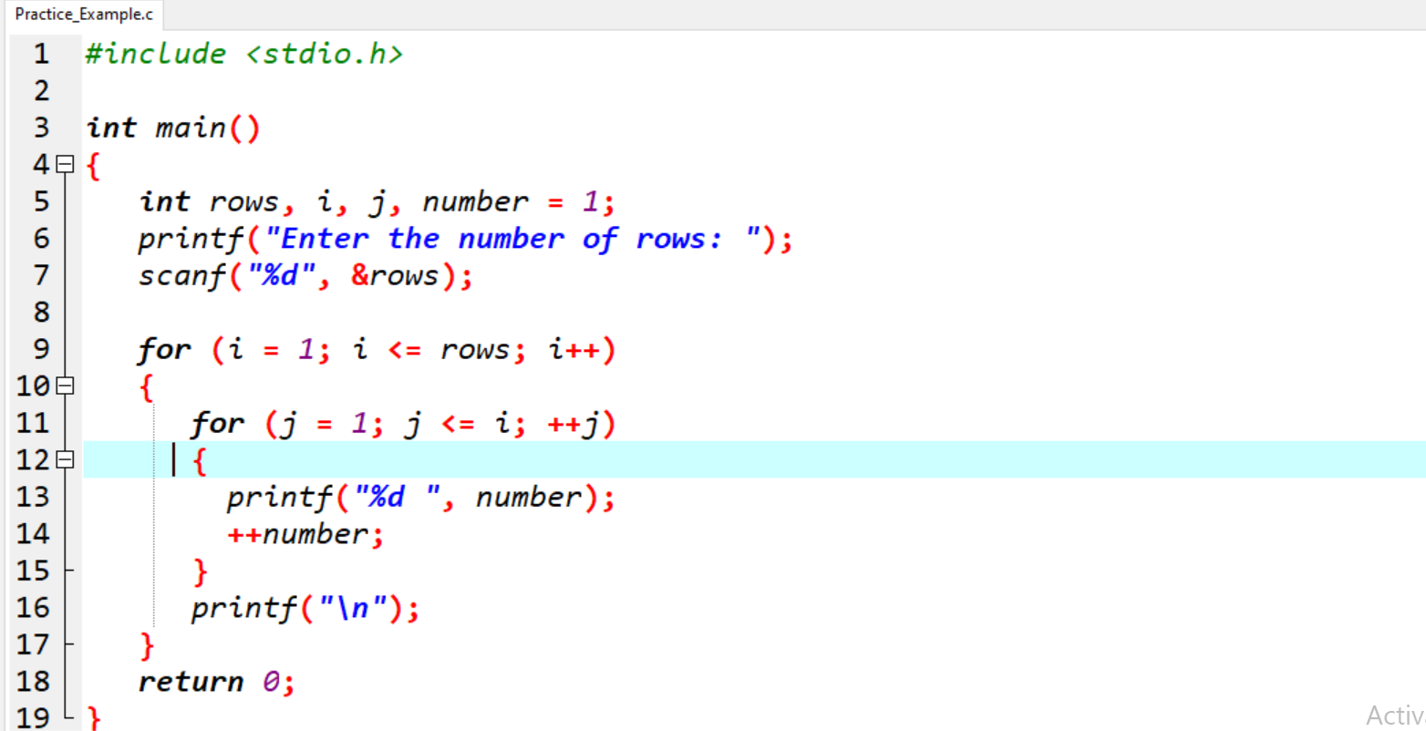

Output:

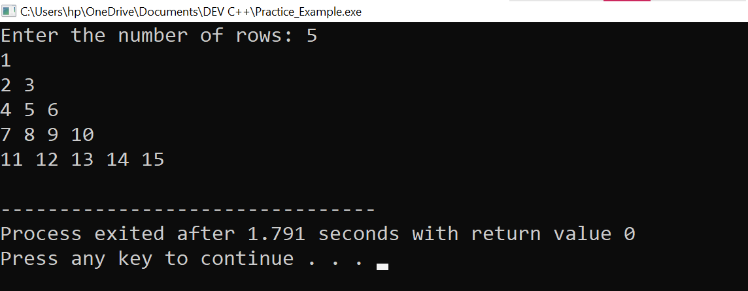

6.

Practical:

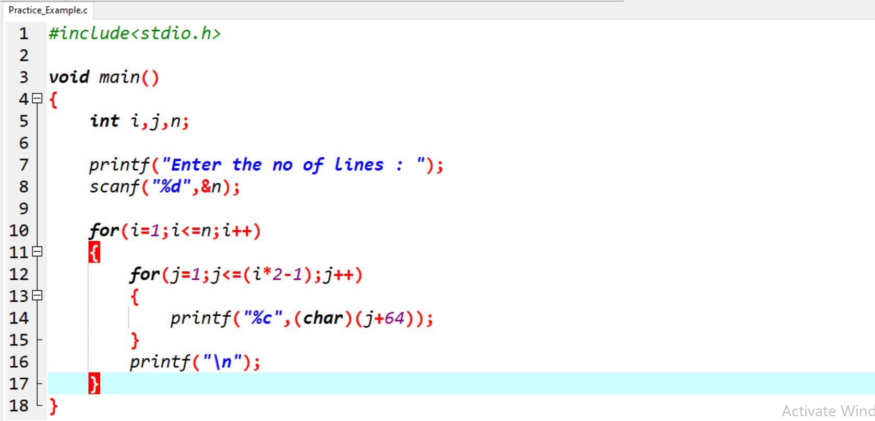

Output:

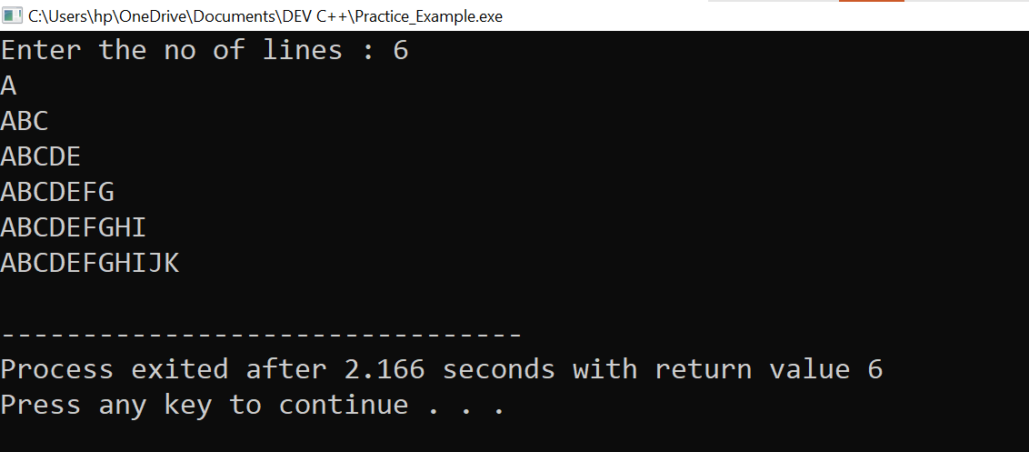

**MODULE: 3.3 (File Handling and Debugging)**

**1. Write a program to find out the max number from given array using function.**

**Ans:-**

Practical:

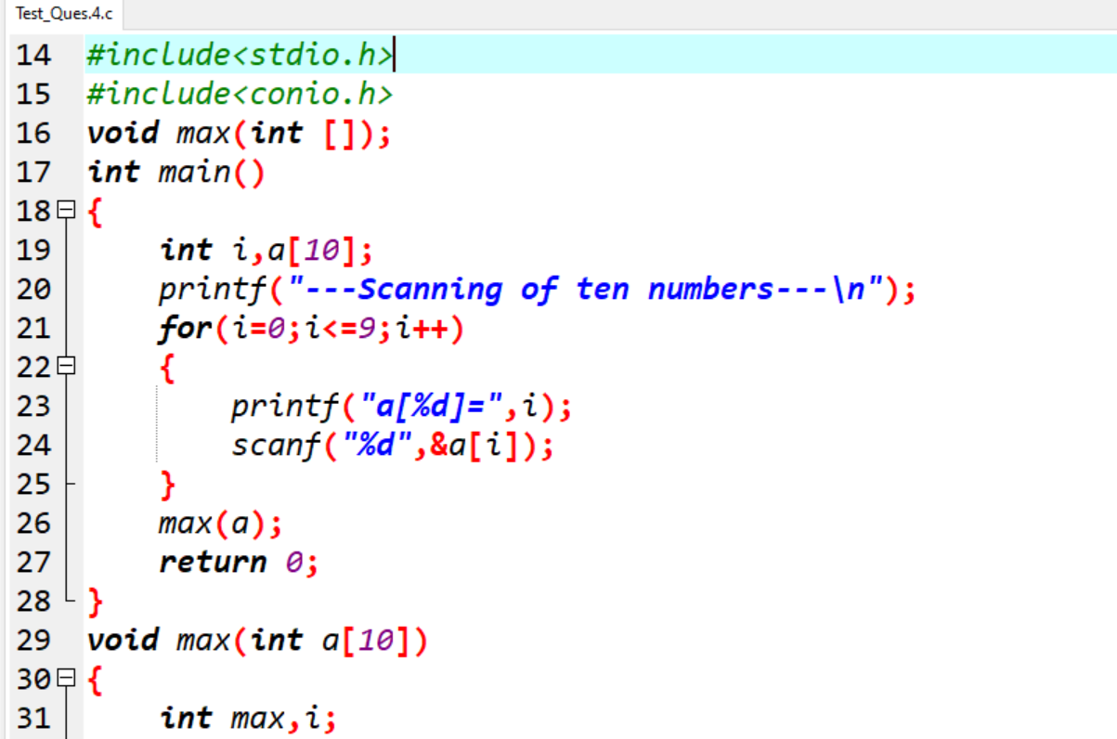

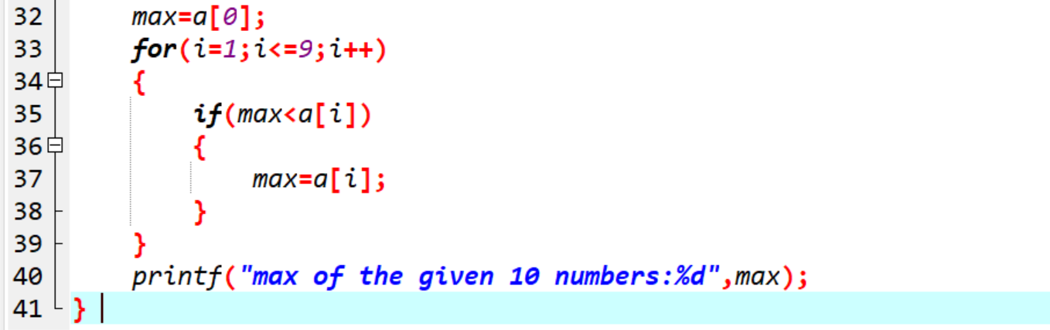

Output:

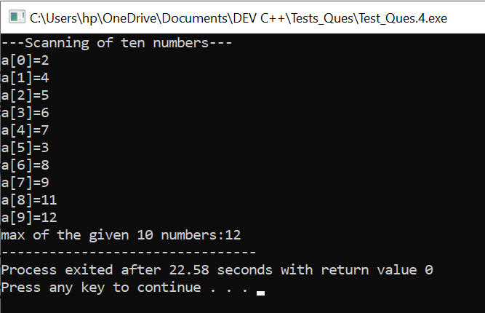

**2.** **WAP of Addition, Subtraction, Multiplication and Division using Switch case.(Must Be Menu Driven).**

**Ans:-**

Practical:

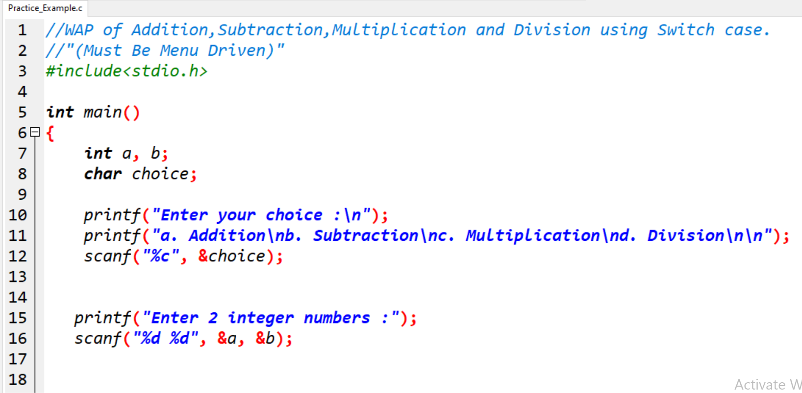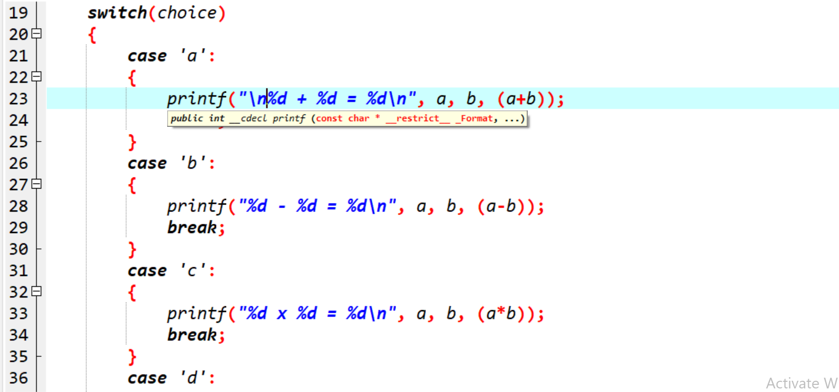

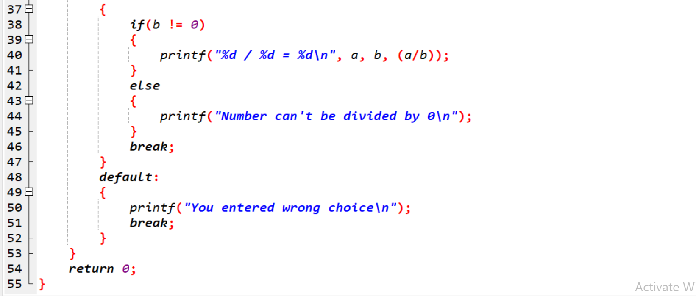

Output:

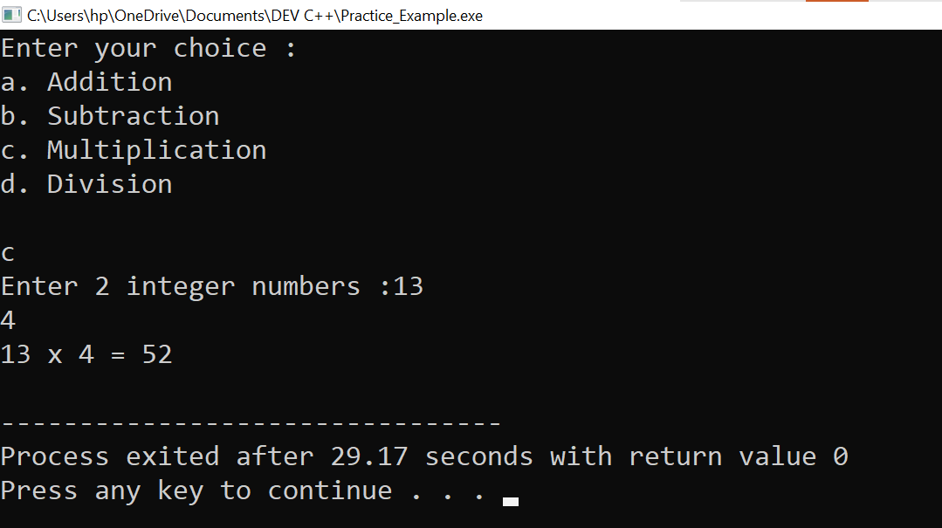

**3.** **WAP to find reverse of string using recursion.**

**Ans:-**

Practical:

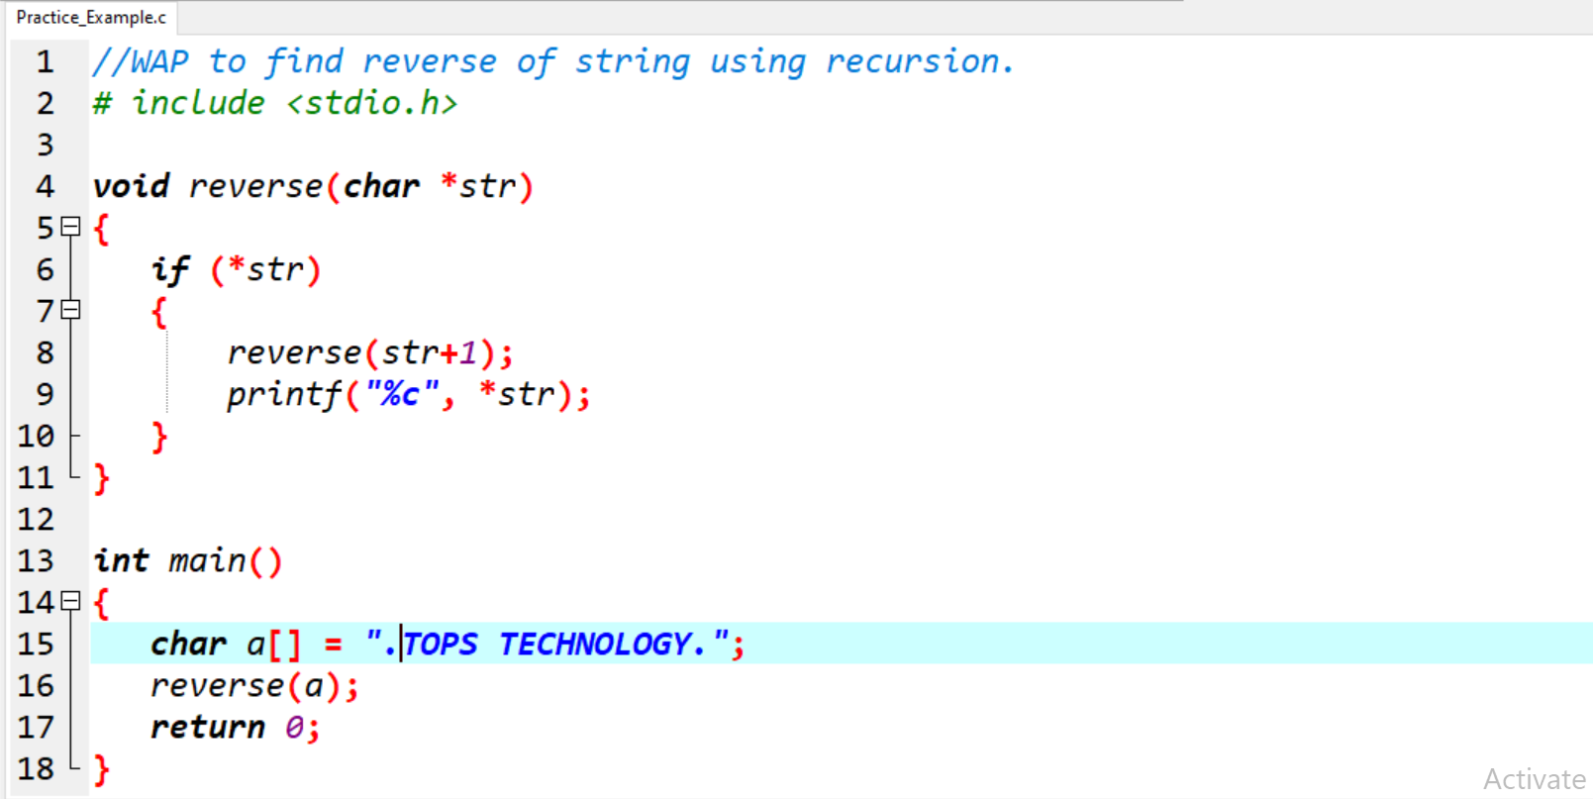

Output:

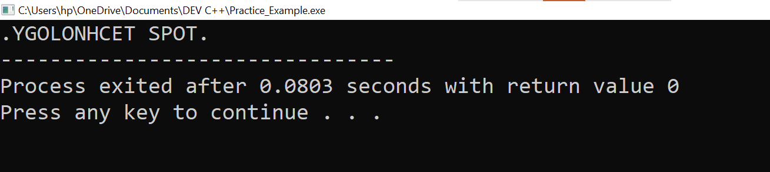

**4. WAP to find factorial using recursion.**

**Ans:-**

Practical:

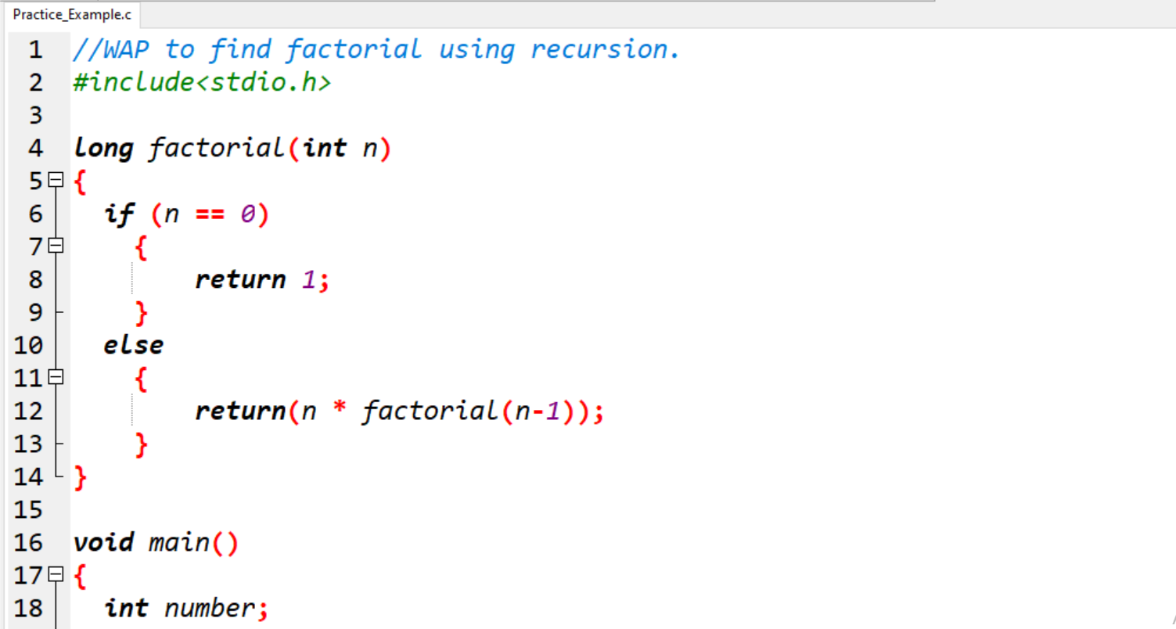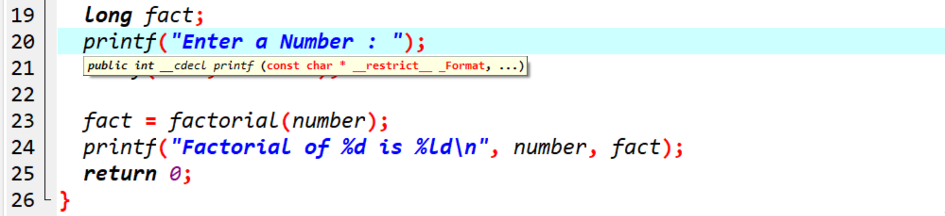

Output: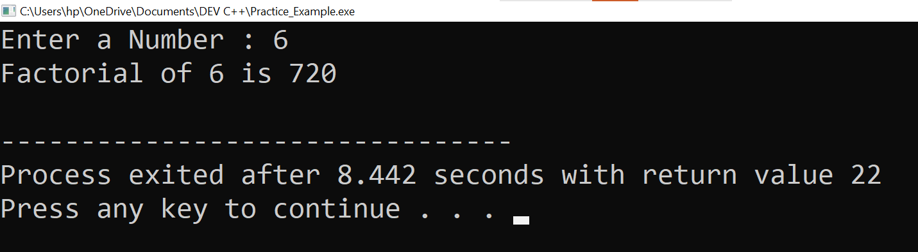

**5.** **WAP to take two Array input from user and sort them in ascending or descending order as per user’s choice.**

**Ans:-**

Practical:

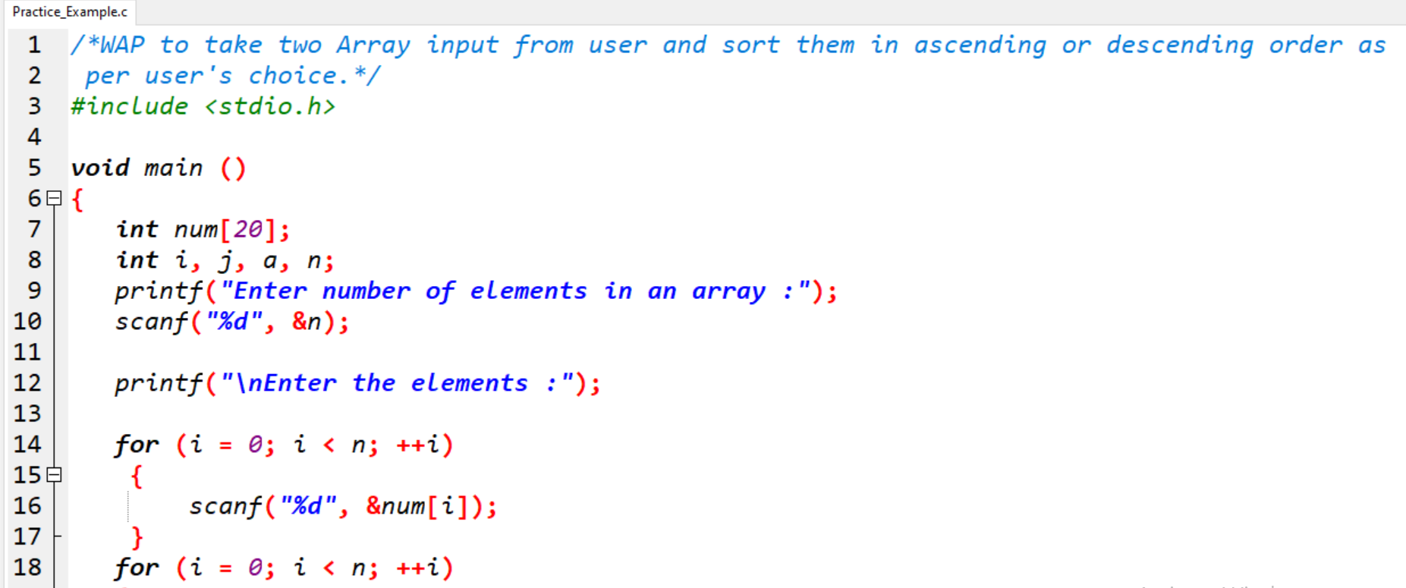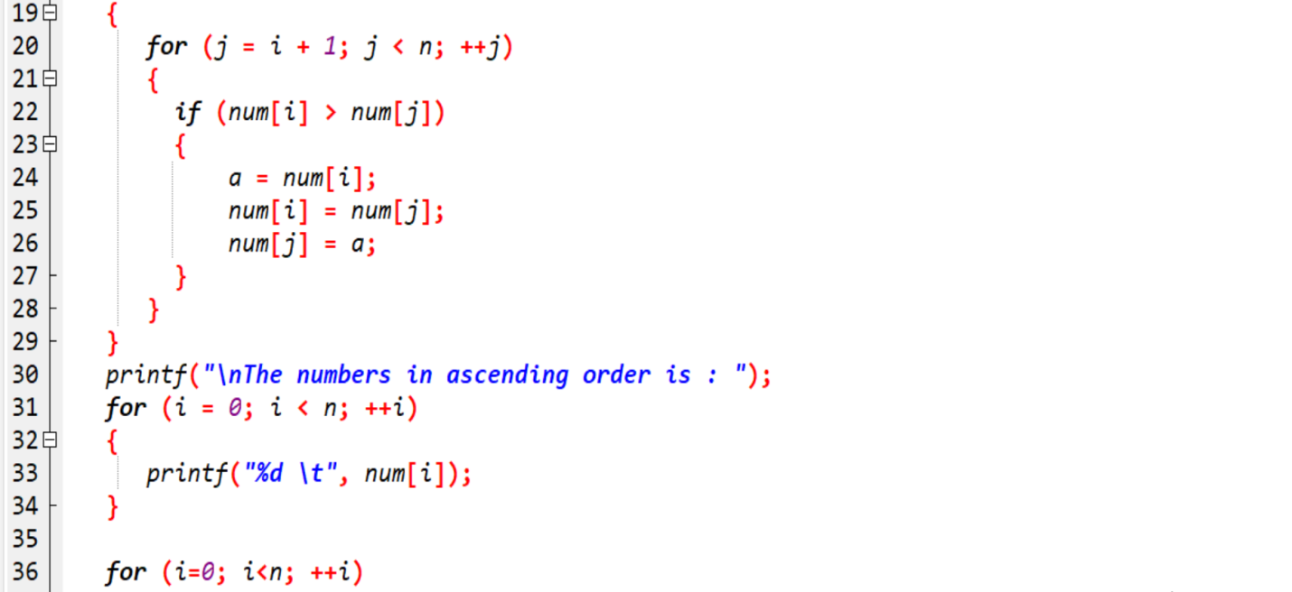

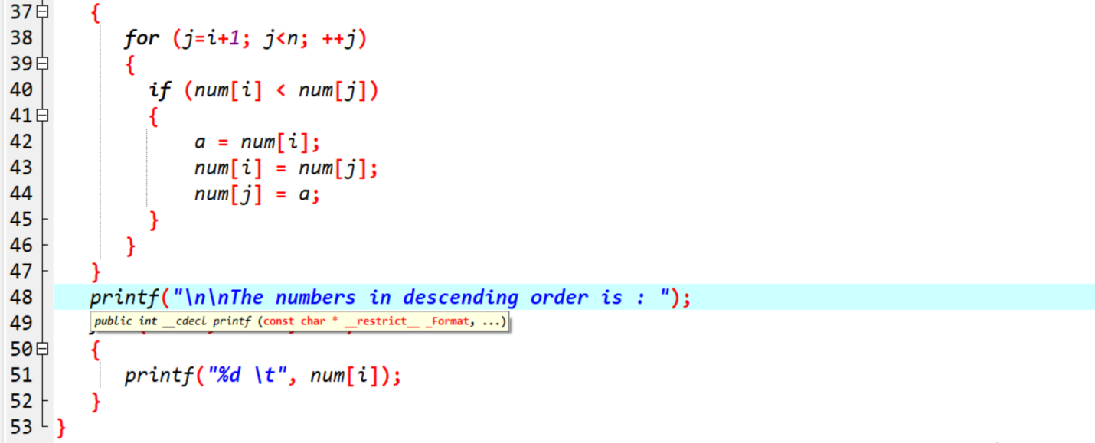

Output:

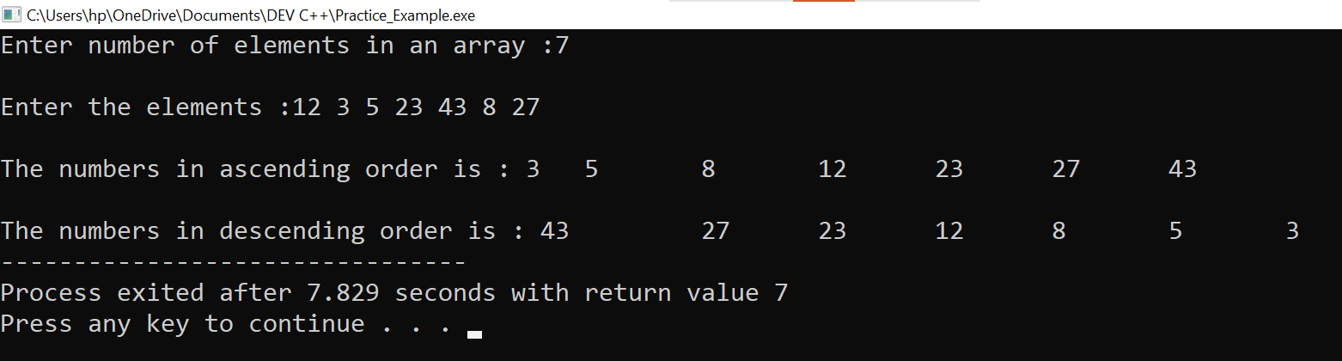

**6. WAP to make addition, Subtraction and multiplication of two matrix using 2-D Array.**

**Ans:-**

Practical:

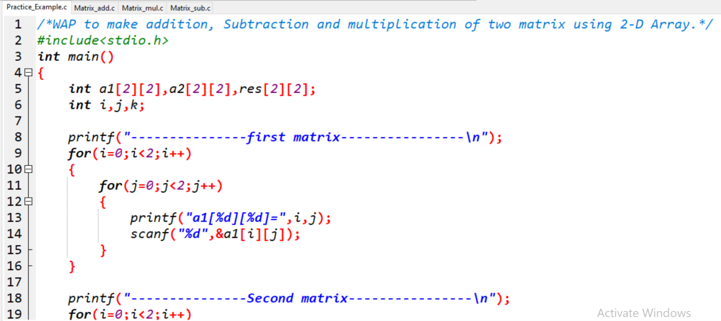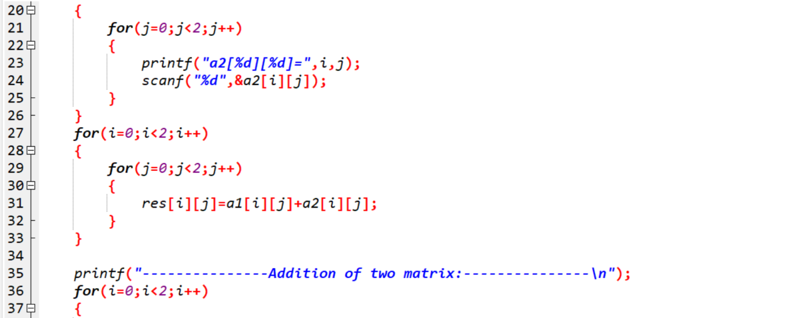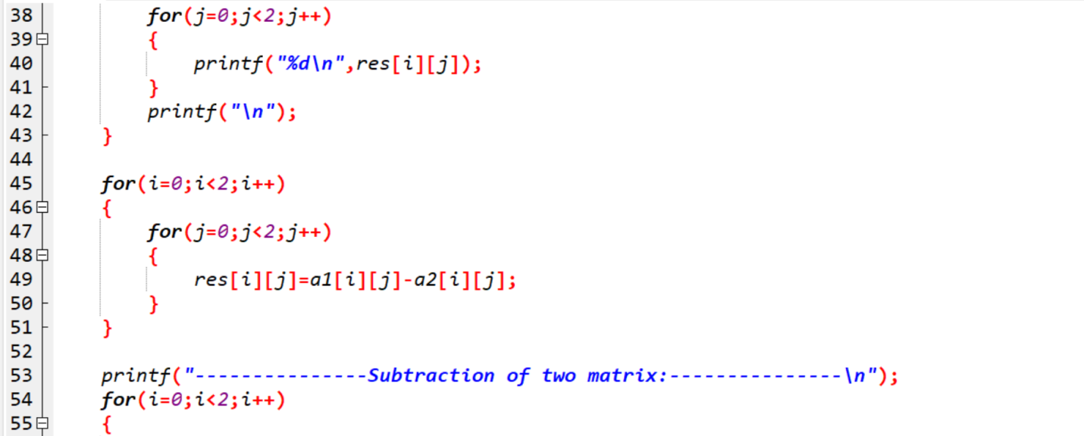

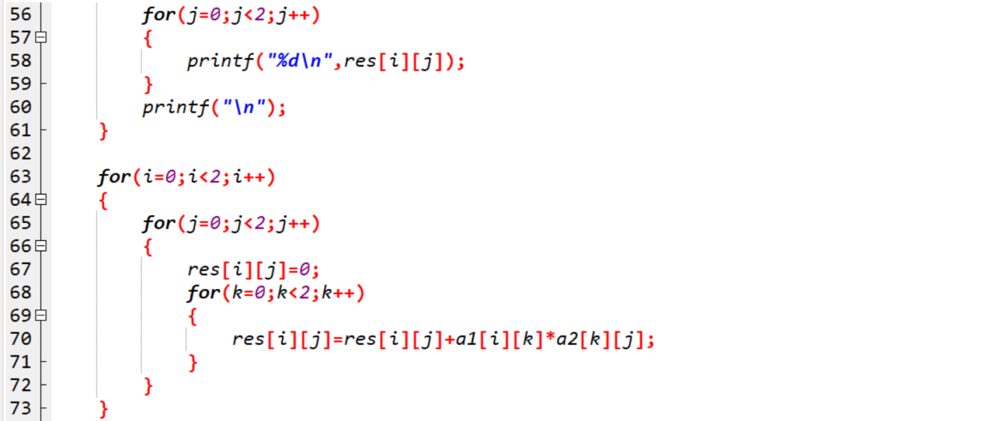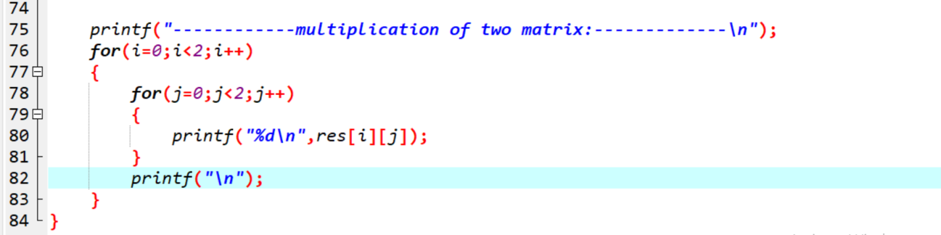

Output: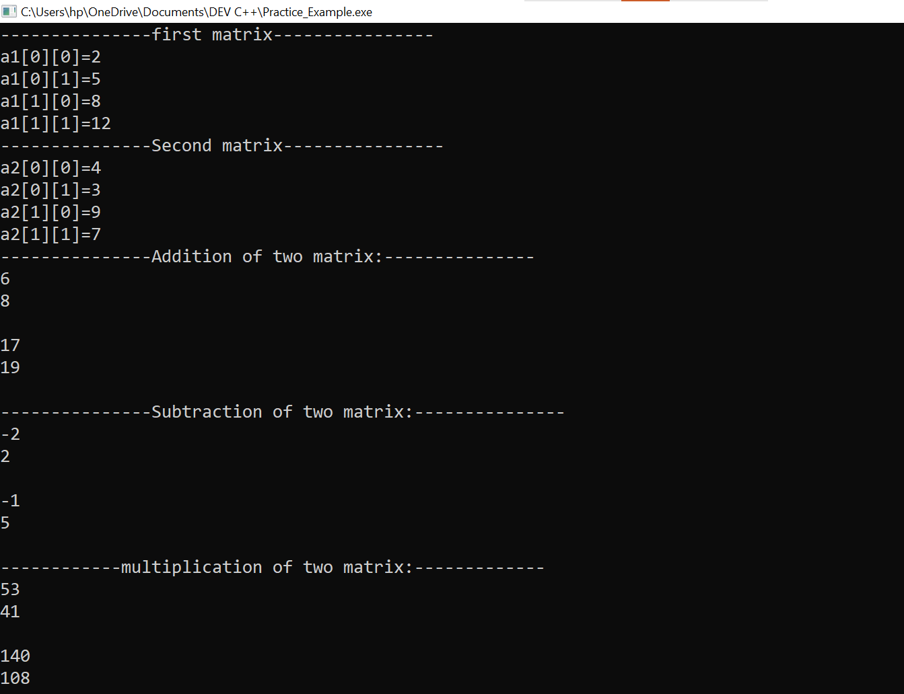

**7.** **WAP Find out length of string without using inbuilt function.**

**Ans:-**

Practical:

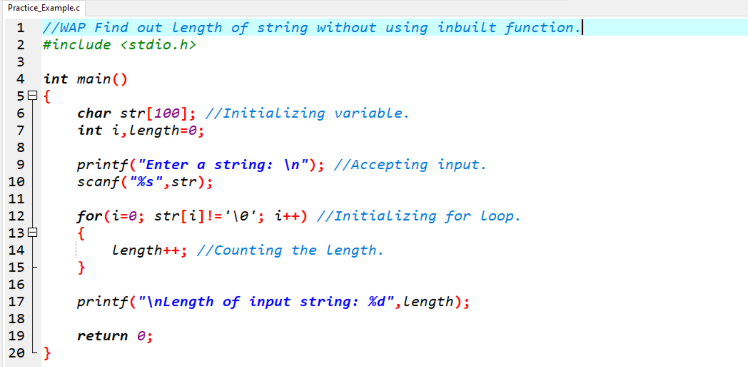

Output:

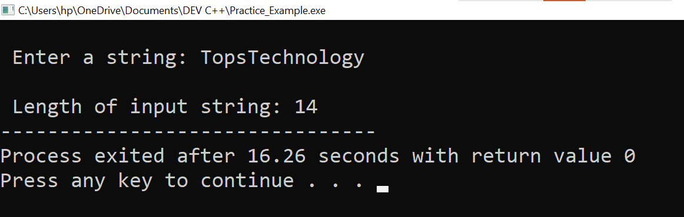

**8. WAP to reverse a string and check that the string is palindrome or not.**

**Ans:-**

Practical:

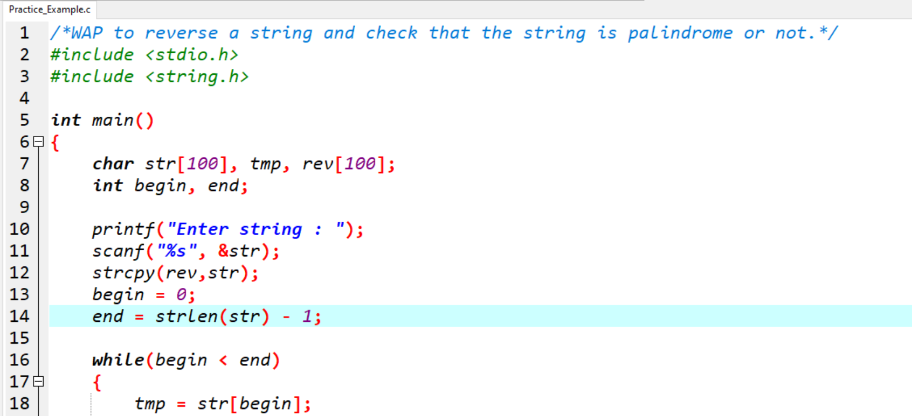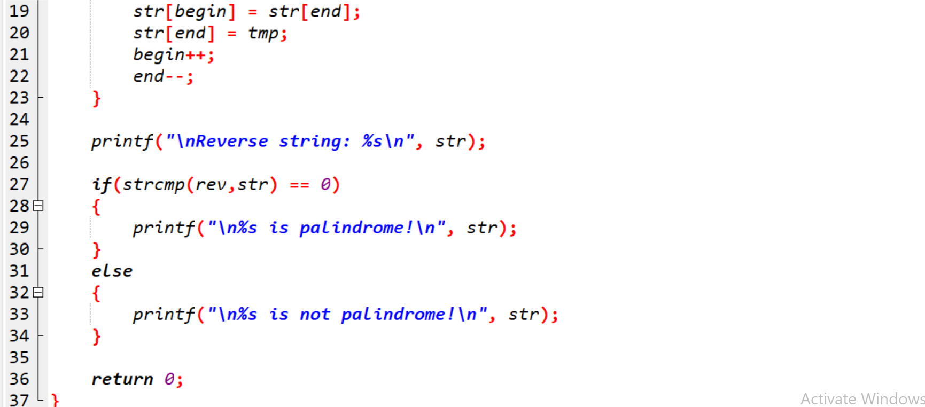

Output:

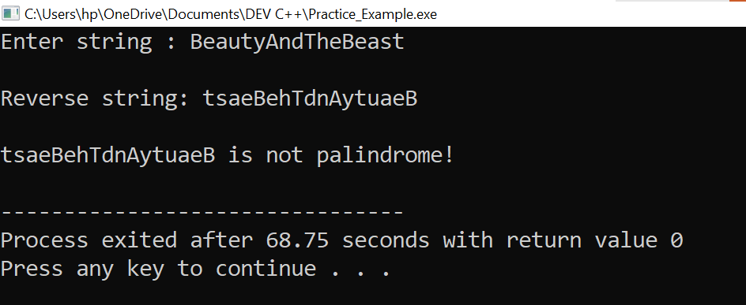

**9. Write a program of structure employee that provides the following information -print and display empno, empname, address and age.**

**Ans:-**

Practical:

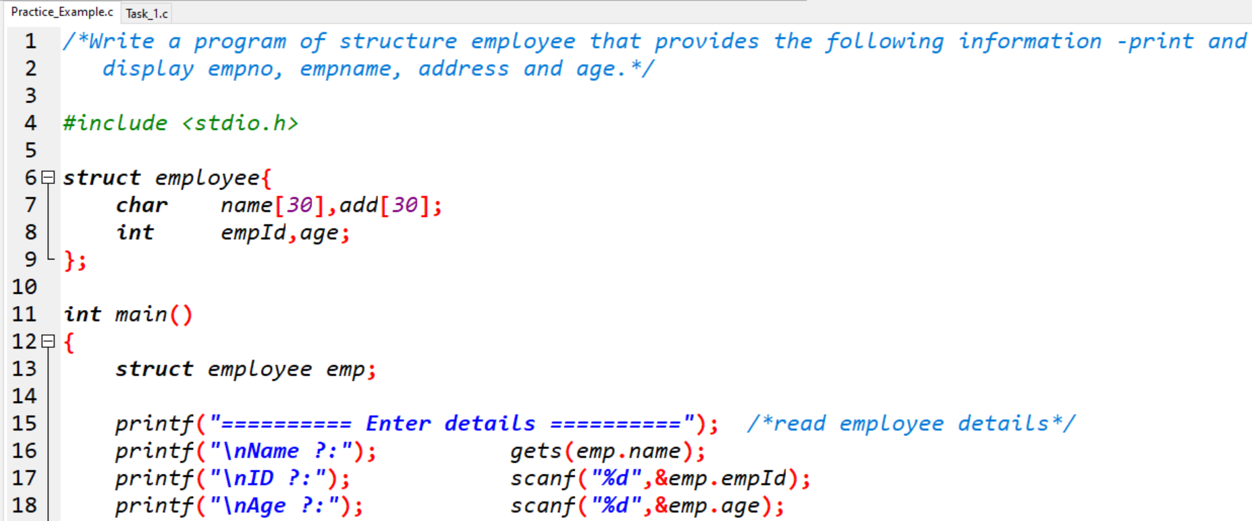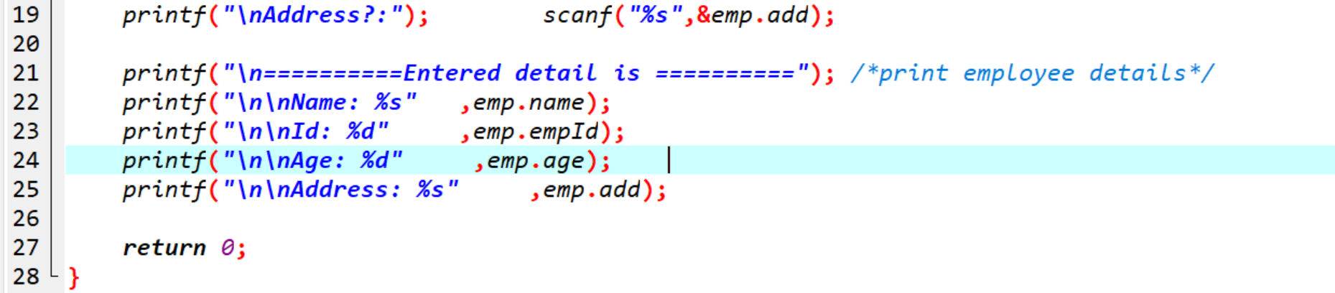

Output:

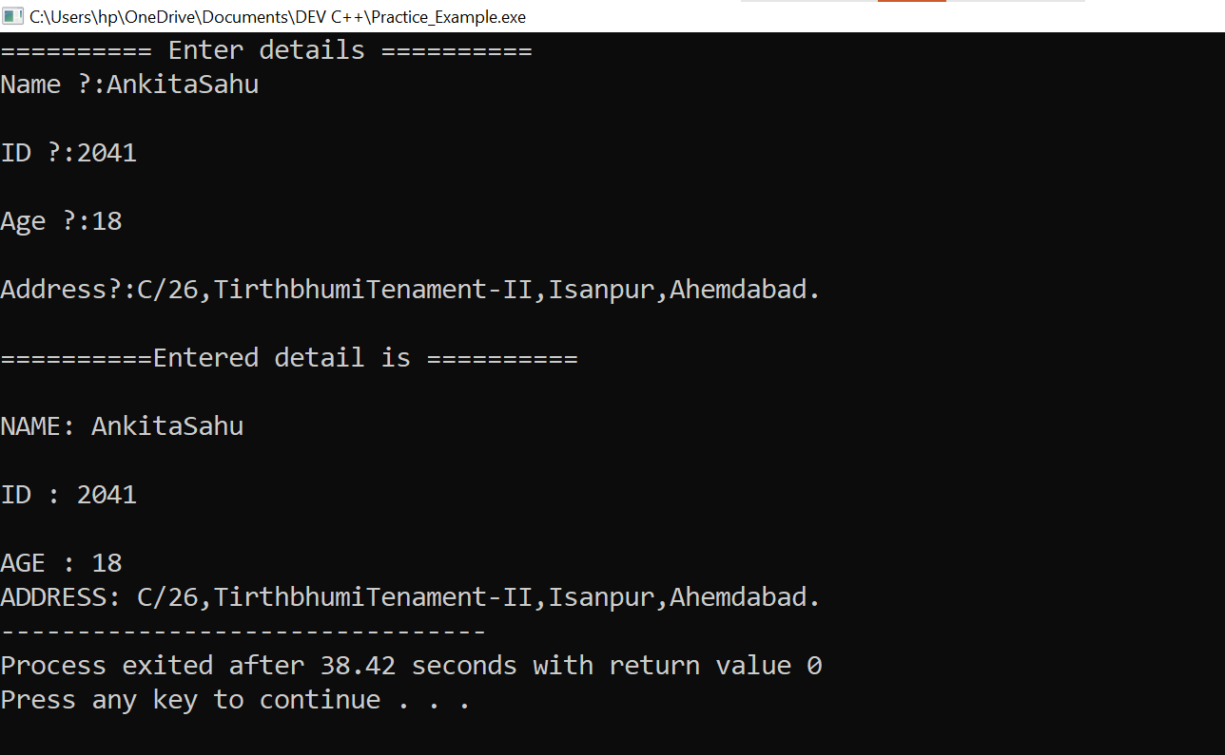

**X0X0X0X0X0X0X0X0X0X**